# Chapter 3 - Set Up and Configure a Cloud Environment in Google Cloud

1.

# Cloud IAM: Qwik Start

45 minutesFree

Rate Lab

## GSP064



## Overview

Google Cloud's Identity and Access Management (IAM) service lets you create and manage permissions for Google Cloud resources. Cloud IAM unifies access control for Google Cloud services into a single system and provides a consistent set of operations. In this hands-on lab you learn how to assign a role to a second user and remove assigned roles associated with Cloud IAM. More specifically, you sign in with 2 different sets of credentials to experience how granting and revoking permissions works from Google Cloud Project Owner and Viewer roles.

## Prerequisites

This is an **introductory level** lab. Little to no prior knowledge of Cloud IAM is expected. Experience with Cloud Storage is helpful to complete the tasks in this lab, but is not required. Make sure that you have a file in .txt or .html available. If you are looking for more advanced practice with Cloud IAM, be sure to check out the following lab:

* [IAM Custom Roles](https://google.qwiklabs.com/catalog_lab/955)

Once you're prepared, scroll down and follow the steps to get your lab environment set up.

## Setup for two users

As mentioned earlier, this lab provides two sets of credentials to illustrate IAM policies and what permissions are available for specific roles.

In the panel on the left-hand side of your lab, you see a list of credentials that resembles the following:

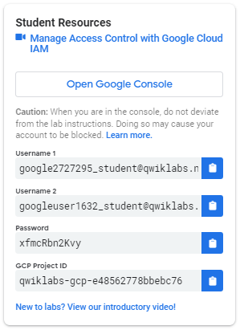

Notice that there are two usernames: Username 1 and Username 2. These represent identities in Cloud IAM, each with different access permissions allocated to them. These "roles" set constraints on what you can and cannot do with Google Cloud resources in the project you've been allocated.

### **Sign in to Cloud Console as the first user**

1. Click on the **Open Google Console** button. This opens a new browser tab. If you are asked to **Choose an account**, click **Use another account**.
2. The Google Cloud sign in page opens. A Sign in page opens—copy and paste the **Username 1** credential that resembles googlexxxxxx_student@qwiklabs.net into the "Email or phone" field and then click **Next**.
3. Copy the password from the "Connection Details" panel and paste into the Google Sign in password field.
4. Click **Next** and then **Accept** the terms of service. The Cloud Console opens. Agree to the terms of service and click **Agree and Continue**:

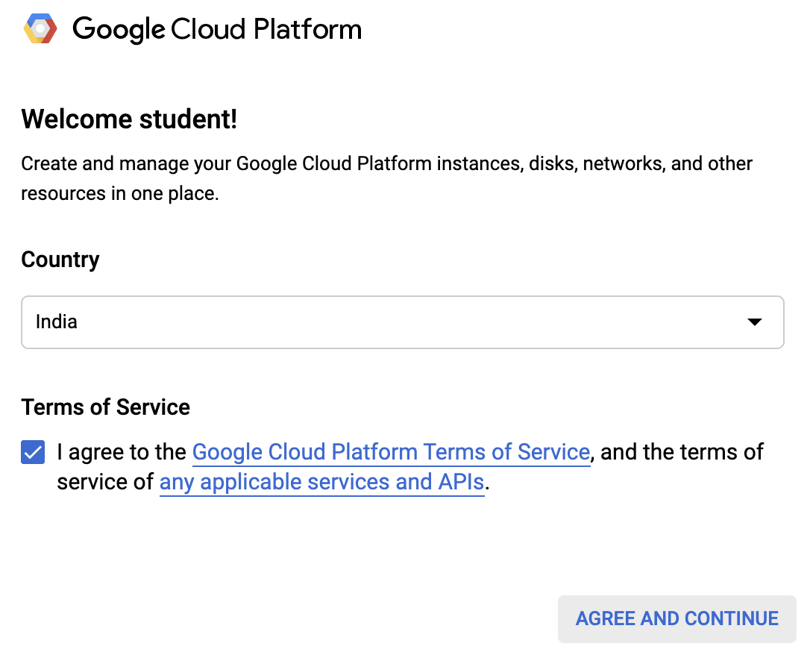

### **Sign in to Cloud Console as the second user**

1. Click on the **Open Google Console** button again. A new browser tab opens, if you are asked to **Choose an account**, click **Use another account**.
2. The Google Cloud sign in page opens. Copy and paste the **Username 2** credential that resembles googlexxxxxx_student@qwiklabs.net into the **Email or phone** field and then click **Next**.
3. Copy the password from the **Connection Details** panel and paste into the Google Sign in password field.
4. Click **Next** and then **Accept** the terms of service. The Cloud Console opens. Agree to the terms of service and and click **Agree and Continue**:



You should now have two Cloud Console tabs open in your browser—one signed in with Username 1 and the other with Username 2.

### **View or reset the user in a browser tab**

Occasionally, a user is overwritten in a browser tab or you may be confused about which user is signed into which browser tab.

To view which user in signed into a browser tab, hover over your Avatar to view your username in that browser tab.

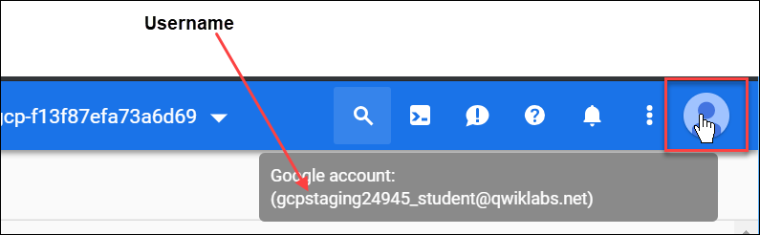

To reset which user is signed into a browser tab:

1. Click your Avatar and click **Sign out** to sign out.
2. In the **Connection Details** panel, click **Open Google Console** and sign in back using the appropriate Username and Password.

## The IAM console and project level roles

1. Return to the **Username 1** Cloud Console page.
2. Select **Navigation menu** > **IAM & Admin** > **IAM**. You are now in the "IAM & Admin" console.
3. Click **+ADD** button at the top of the page and explore the project roles associated with Projects by clicking on the "Select a role" dropdown menu:



You should see Browser, Editor, Owner, and Viewer roles. These four are known as primitive roles in Google Cloud. Primitive roles set project-level permissions and unless otherwise specified, they control access and management to all Google Cloud services.

The following table pulls definitions from the [Google Cloud roles documentation](https://cloud.google.com/iam/docs/understanding-roles#primitive_roles), which gives a brief overview of browser, viewer, editor, and owner role permissions:

|  |  |
| --- | --- |
| **Role Name** | **Permissions** |
| roles/viewer | Permissions for read-only actions that do not affect state, such as viewing (but not modifying) existing resources or data. |
| roles/editor | All viewer permissions, plus permissions for actions that modify state, such as changing existing resources. |
| roles/owner | All editor permissions and permissions for the following actions:   * Manage roles and permissions for a project and all resources within the project. * Set up billing for a project. |
| roles/browser (beta) | Read access to browse the hierarchy for a project, including the folder, organization, and Cloud IAM policy. This role doesn't include permission to view resources in the project. |

Since you are able to manage roles and permissions for this project, Username 1 has Project owner permissions.

1. Click **CANCEL** to exit out of the "Add member" panel.

## Explore editor roles

Now switch to the **Username 2** console.

1. Navigate to the IAM & Admin console, select **Navigation menu** > **IAM & Admin** > **IAM**.
2. Search through the table to find Username 1 and Username 2 and examine the roles they are granted. You should see something like this:

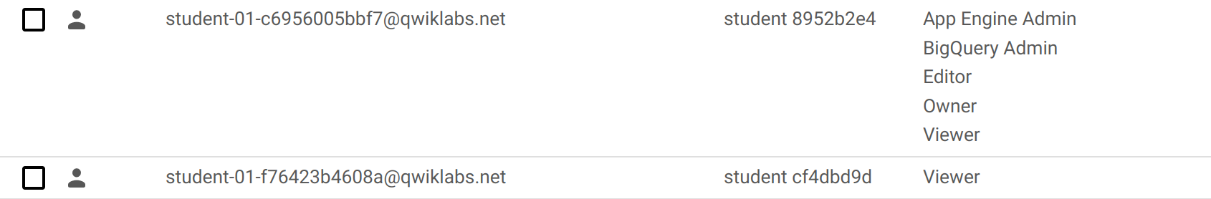

You should see:

* Username 2 has the "Viewer" role granted to it.
* The **+ADD** button at the top is grayed out—if you try to click on it you get the following message:

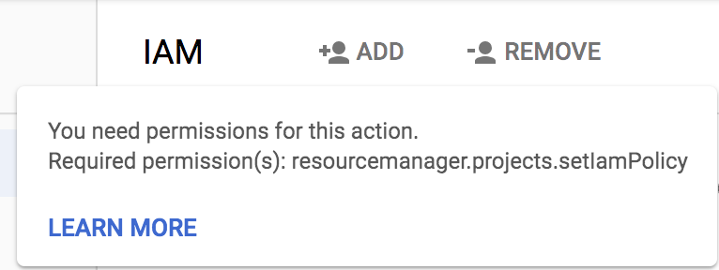

This is one example of how IAM roles affect what you can and cannot do in Google Cloud.

1. Switch back to the **Username 1** console for the next step.

## Prepare a resource for access testing

Ensure that you are in the **Username 1** Cloud Console.

### **Create a bucket**

1. Create a Cloud Storage bucket with a unique name. From the Cloud Console, select **Navigation menu** > **Storage** > **Browser**.
2. Click **Create bucket**.

**Note**: If you get a permissions error for bucket creation, sign out and then sign in back in with the Username 1 credentials.

1. Update the following fields, leave all others at their default values:

|  |  |
| --- | --- |
| **Property** | **Value** |
| **Name**: | globally unique name (create it yourself!) and click ***Continue***. |
| **Location Type:** | Multi-Region |

Note the bucket name. You will use it in a later step.

1. Click **Create.**

**Note**: If you get a permissions error for bucket creation, sign out and then sign in back in with the Username 1 credentials.

### **Upload a sample file**

1. On the Bucket Details page click **Upload files** button.
2. Browse your computer to find a file to use. Any text or html file will do.
3. Click on the three dots at the end of the line containing the file and click **Rename**.
4. Rename the file ‘sample.txt'.
5. Click **Rename**.

Click **Check my progress** to verify the objective.

Create a bucket and upload a sample file

Check my progress

### **Verify project viewer access**

1. Switch to the **Username 2** console.
2. From the Console, select **Navigation menu** > **Storage** > **Browser**. Verify that this user can see the bucket.

Username 2 has the "Viewer" role prescribed which allows them read-only actions that do not affect state. This example illustrates this feature—they can view Cloud Storage buckets and files that are hosted in the Google Cloud project that they've been granted access to.

## Remove project access

Switch to the **Username 1** console.

### **Remove Project Viewer for Username 2**

1. Select **Navigation menu** > **IAM & Admin** > **IAM**. Then click the pencil icon next to **Username 2**.

You may have to widen the screen to see the pencil icon.

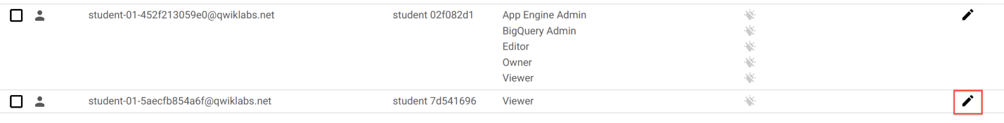

1. Remove Project Viewer access for **Username 2** by clicking the trashcan icon next to the role name. Then click **SAVE**.

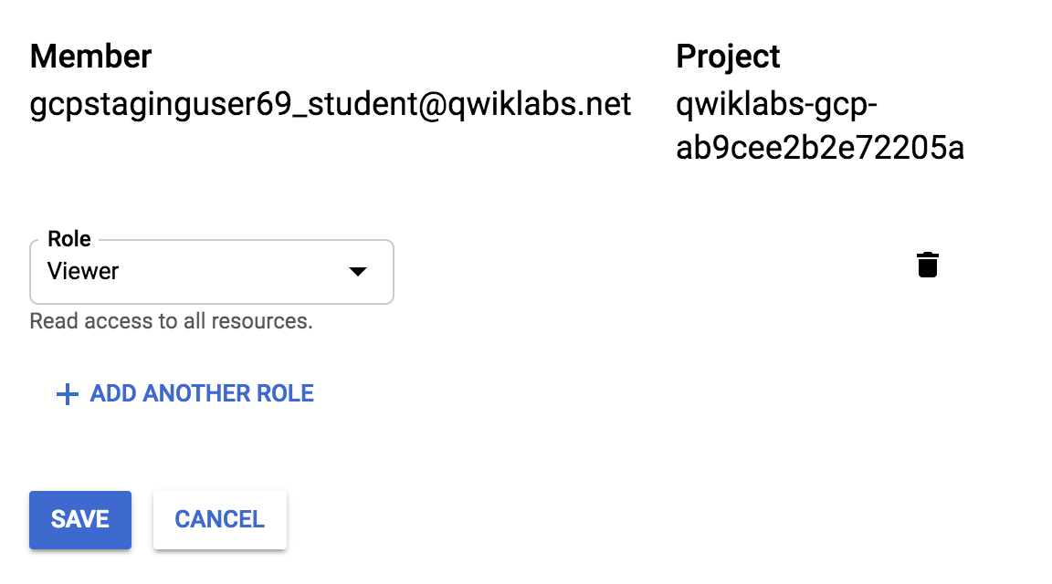

Notice that the user has disappeared from the list! The user has no access now.

**Note**: It can take up to 80 seconds for such a change to take effect as it propagates. Read more [here](https://cloud.google.com/iam/docs/faq).

### **Verify that Username 2 has lost access**

1. Switch to **Username 2** Cloud Console. Ensure that you are still signed in with Username 2's credentials and that you haven't been signed out of the project after permissions were revoked. If signed out, sign in back with the proper credentials.
2. Navigate back to Cloud Storage by selecting **Navigation menu** > **Storage** > **Browser**.

You should see a permission error.

**Note**: As mentioned before, it can take up to 80 seconds for permissions to be revoked. If you haven't received a permission error, wait a 2 minutes and then try refreshing the console.

Click **Check my progress** to verify the objective.

Remove project access

Check my progress

## Add Storage permissions

1. Copy **Username 2** name from the Qwiklabs "Connection Details" panel.



1. Switch to **Username 1** console. Ensure that you are still signed in with Username 1's credentials. If you are signed out, sign in back with the proper credentials.
2. In the Console, select **Navigation menu** > **IAM & Admin** > **IAM**.
3. Click **+ ADD** button and paste the **Username 2** name into the New members field.
4. In the **Roles** field, select **Cloud Storage** > **Storage Object Viewer** from the drop-down menu.
5. Click **SAVE**.

## Verify access

1. Switch to the **Username 2** console. You'll still be on the Storage page.

**Username 2** doesn't have the Project Viewer role, so that user can't see the project or any of its resources in the Console. However, this user has specific access to Cloud Storage, the Storage Object Viewer role - check it out now.

1. Click the **Activate Cloud Shell** icon to open the Cloud Shell command line.



1. Open up a Cloud Shell session and then enter in the following command, replace [YOUR_BUCKET_NAME] with the name of the bucket you created earlier:

gsutil ls gs://[YOUR_BUCKET_NAME]content_copy

You should receive a similar output:

gs://[YOUR_BUCKET_NAME]/sample.txtcontent_copy

1. As you can see, you gave **Username 2** view access to the Cloud Storage bucket.

Click **Check my progress** to verify the objective.

Add Storage permissions

Check my progress

.

2.

# Introduction to SQL for BigQuery and Cloud SQL

1 hour 15 minutesFree

Rate Lab

## GSP281



## Overview

SQL (Structured Query Language) is a standard language for data operations that allows you to ask questions and get insights from structured datasets. It's commonly used in database management and allows you to perform tasks like transaction record writing into relational databases and petabyte-scale data analysis.

This lab serves as an introduction to SQL and is intended to prepare you for the many labs and quests in Qwiklabs on data science topics. This lab is divided into two parts: in the first half, you will learn fundamental SQL querying keywords, which you will run in the BigQuery console on a public dataset that contains information on London bikeshares.

In the second half, you will learn how to export subsets of the London bikeshare dataset into CSV files, which you will then upload to Cloud SQL. From there you will learn how to use Cloud SQL to create and manage databases and tables. Towards the end, you will get hands-on practice with additional SQL keywords that manipulate and edit data.

### **Objectives**

In this lab, you will learn how to:

* Distinguish databases from tables and projects.
* Use the SELECT, FROM, and WHERE keywords to construct simple queries.
* Identify the different components and hierarchies within the BigQuery console.
* Load databases and tables into BigQuery.
* Execute simple queries on tables.
* Learn about the COUNT, GROUP BY, AS, and ORDER BY keywords.
* Execute and chain the above commands to pull meaningful data from datasets.
* Export a subset of data into a CSV file and store that file into a new Cloud Storage bucket.
* Create a new Cloud SQL instance and load your exported CSV file as a new table.
* Run CREATE DATABASE, CREATE TABLE, DELETE, INSERT INTO, and UNION queries in Cloud SQL.

### **Prerequisites**

**Very Important:** Before starting this lab, log out of your personal or corporate gmail account.

This is a **introductory level** lab. This assumes little to no prior experience with SQL. Familiarity with Cloud Storage and Cloud Shell is recommended, but not required. This lab will teach you the basics of reading and writing queries in SQL, which you will apply by using BigQuery and Cloud SQL.

Before taking this lab, consider your proficiency in SQL. Below are more challenging labs that will let you apply your knowledge to more advanced use cases:

* [Weather Data in BigQuery](https://google.qwiklabs.com/catalog_lab/476)
* [Analyzing Natality Data Using Datalab and BigQuery](https://google.qwiklabs.com/catalog_lab/479)

Once you're ready, scroll down and follow the steps below to get your lab environment set up.

## Setup and Requirements

#### Before you click the Start Lab button

Read these instructions. Labs are timed and you cannot pause them. The timer, which starts when you click **Start Lab**, shows how long Google Cloud resources will be made available to you.

This Qwiklabs hands-on lab lets you do the lab activities yourself in a real cloud environment, not in a simulation or demo environment. It does so by giving you new, temporary credentials that you use to sign in and access Google Cloud for the duration of the lab.

#### What you need

To complete this lab, you need:

* Access to a standard internet browser (Chrome browser recommended).
* Time to complete the lab.

**Note:** If you already have your own personal Google Cloud account or project, do not use it for this lab.

**Note:** If you are using a Pixelbook, open an Incognito window to run this lab.

#### How to start your lab and sign in to the Google Cloud Console

1. Click the **Start Lab** button. If you need to pay for the lab, a pop-up opens for you to select your payment method. On the left is a panel populated with the temporary credentials that you must use for this lab.

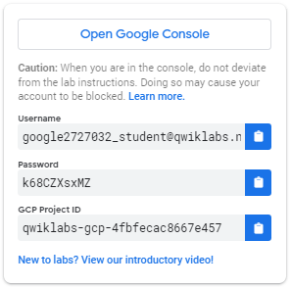

1. Copy the username, and then click **Open Google Console**. The lab spins up resources, and then opens another tab that shows the **Sign in** page.

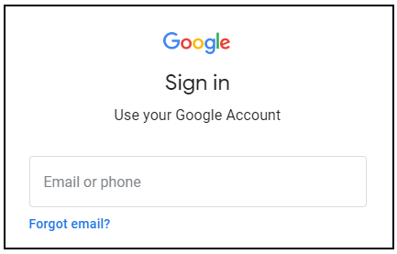

**Tip:** Open the tabs in separate windows, side-by-side.

If you see the **Choose an account** page, click **Use Another Account**. 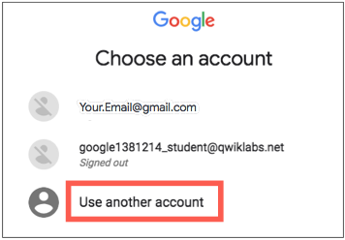

1. In the **Sign in** page, paste the username that you copied from the Connection Details panel. Then copy and paste the password.

**Important:** You must use the credentials from the Connection Details panel. Do not use your Qwiklabs credentials. If you have your own Google Cloud account, do not use it for this lab (avoids incurring charges).

1. Click through the subsequent pages:
   * Accept the terms and conditions.
   * Do not add recovery options or two-factor authentication (because this is a temporary account).
   * Do not sign up for free trials.

After a few moments, the Cloud Console opens in this tab.

**Note:** You can view the menu with a list of Google Cloud Products and Services by clicking the **Navigation menu** at the top-left. 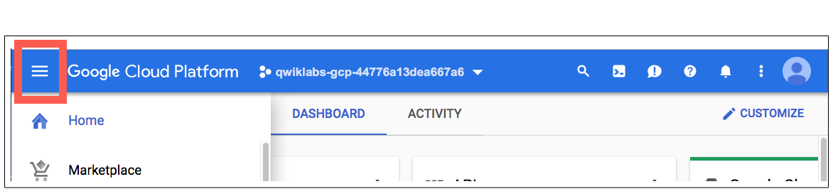

## The Basics of SQL

### **Databases and Tables**

As mentioned earlier, SQL allows you to get information from "structured datasets". Structured datasets have clear rules and formatting and often times are organized into tables, or data that's formatted in rows and columns.

An example of unstructured data would be an image file. Unstructured data is inoperable with SQL and cannot be stored in BigQuery datasets or tables (at least natively.) To work with image data (for instance), you would use a service like [Cloud Vision](https://google.qwiklabs.com/catalog_lab/1112), perhaps through its [API](https://google.qwiklabs.com/catalog_lab/1241) directly.

The following is an example of a structured dataset—a simple table:

|  |  |  |
| --- | --- | --- |
| **User** | **Price** | **Shipped** |
| Sean | $35 | Yes |
| Rocky | $50 | No |

If you've had experience with Google Sheets, then the above should look quite similar. As we see, the table has columns for User, Price, and Shipped and two rows that are composed of filled in column values.

A Database is essentially a collection of one or more tables. SQL is a structured database management tool, but quite often (and in this lab) you will be running queries on one or a few tables joined together—not on whole databases.

### **SELECT and FROM**

SQL is phonetic by nature and before running a query, it's always helpful to first figure out what question you want to ask your data (unless you're just exploring for fun.)

SQL has predefined keywords which you use to translate your question into the pseudo-english SQL syntax so you can get the database engine to return the answer you want.

The most essential keywords are SELECT and FROM:

* Use SELECT to specify what fields you want to pull from your dataset.
* Use FROM to specify what table or tables we want to pull our data from.

An example may help understanding. Assume that we have the following table example_table, which has columns USER, PRICE, and SHIPPED:

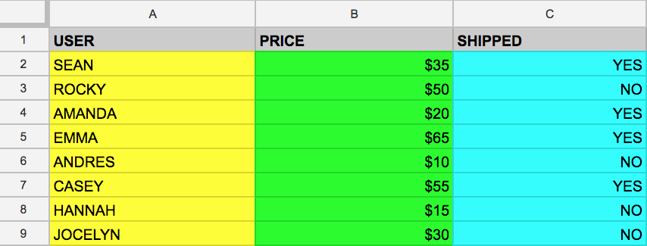

And let's say that we want to just pull the data that's found in the USER column. We can do this by running the following query that uses SELECT and FROM:

SELECT USER FROM example_table

content_copy

If we executed the above command, we would select all the names from the USER column that are found in example_table.

You can also select multiple columns with the SQL SELECT keyword. Say that you want to pull the data that's found in the USER and SHIPPED columns. To do this, modify the previous query by adding another column value to our SELECT query (making sure it's separated by a comma!):

SELECT USER, SHIPPED FROM example_table

content_copy

Running the above retrieves the USER and the SHIPPED data from memory:

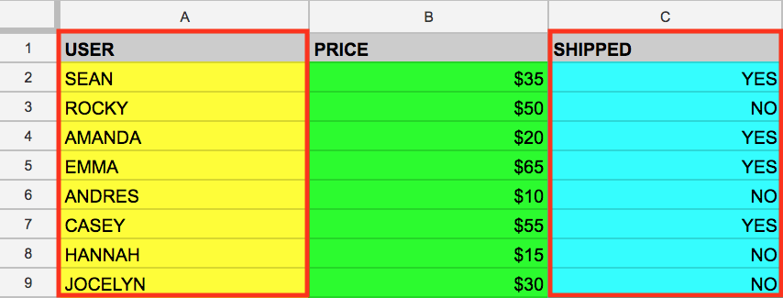

And just like that you've covered two fundamental SQL keywords! Now to make things a bit more interesting.

### **WHERE**

The WHERE keyword is another SQL command that filters tables for specific column values. Say that you want to pull the names from example_table whose packages were shipped. You can supplement the query with a WHERE, like the following:

SELECT USER FROM example_table WHERE SHIPPED='YES'

content_copy

Running the above returns all USERs whose packages have been SHIPPED to from memory:

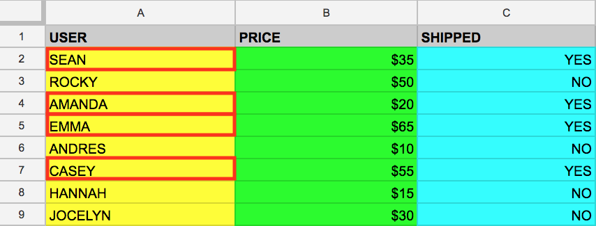

Now that you have a baseline understanding of SQL's core keywords, apply what you've learned by running these types of queries in the BigQuery console.

### **Test your understanding**

The following are some multiple choice questions to reinforce your understanding of the concepts covered so far. Answer them to the best of your abilities.

A keyword that specifies the fields (e.g. column values) that you want to pull from your dataset.



FROM



WHERE



SELECT

Submit

Specifies what table or tables we want to pull our data from.



WHERE



SELECT



FROM

Submit

Allows us to filter tables for specific column values.



WHERE



SELECT



FROM

Submit

## Exploring the BigQuery Console

### **The BigQuery paradigm**

[BigQuery](https://cloud.google.com/bigquery/) is a fully-managed petabyte-scale data warehouse that runs on the Google Cloud. Data analysts and data scientists can quickly query and filter large datasets, aggregate results, and perform complex operations without having to worry about setting up and managing servers. It comes in the form of a command line tool (preinstalled in cloudshell) or a web console—both ready for managing and querying data housed in Google Cloud projects.

In this lab, you use the web console to run SQL queries.

### **Open BigQuery Console**

In the Google Cloud Console, select **Navigation menu** > **BigQuery**:

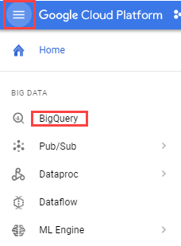

The **Welcome to BigQuery in the Cloud Console** message box opens. This message box provides a link to the quickstart guide and the release notes.

Click **Done**.

The BigQuery console opens.

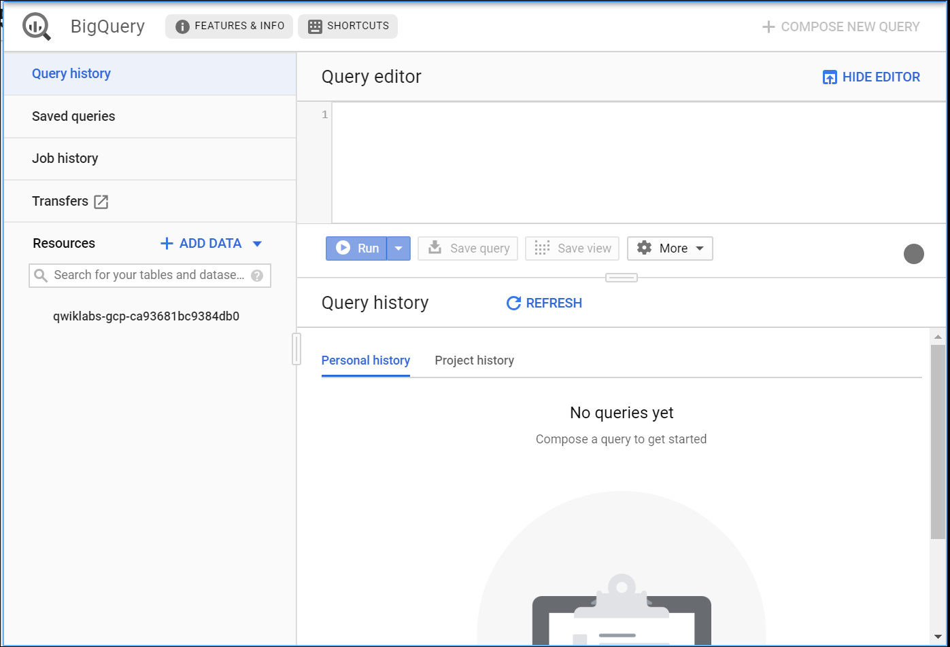

Take a moment to note some important features of the UI. The right-hand side of the console houses the "Query editor". This is where you write and run SQL commands like the examples we covered earlier. Below that is "Query history", which is a list of queries you ran previously.

The left pane of the console is the "Navigation panel". Apart from the self-explanatory query history, saved queries, and job history, there is the Resources tab.

The highest level of resources contain Google Cloud projects, which are just like the temporary Google Cloud projects you sign in to and use with each Qwiklab. As you can see in your console and in the last screenshot, we only have our Qwiklabs project housed in the Resources tab. If you try clicking on the arrow next the project name, nothing will show up.

This is because your project doesn't contain any datasets or tables, you have nothing that can be queried. Earlier you learned datasets contain tables. When you add data to your project, note that in BigQuery, projects contain datasets, and datasets contain tables. Now that you better understand the project → dataset → table paradigm and the intricacies of the console, you can load up some queryable data.

### **Uploading queryable data**

In this section you pull in some public data into your project so you can practice running SQL commands in BigQuery.

Click on the **+ ADD DATA** link then select **Explore public datasets**:

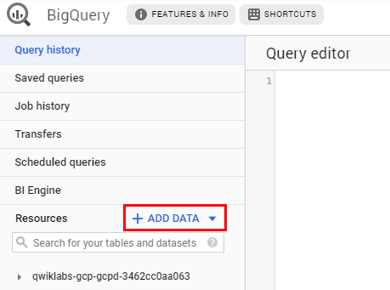

In the search bar, enter "london", then select the **London Bicycle Hires** tile, then **View Dataset**.

A new tab will open, and you will now have a new project called bigquery-public-data added to the Resources panel:

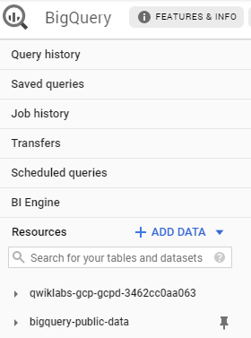

It's important to note that you are still working out of your lab project in this new tab. All you did was pull a publicly accessible project that contains datasets and tables into BigQuery for analysis — you didn't switch over to that project. All of your jobs and services are still tied to your Qwiklabs account. You can see this for yourself by inspecting the project field near the top of the console:

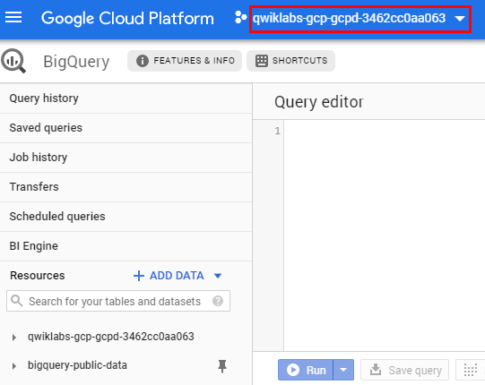

Click on **bigquery-public-data** > **london_bicycles** > **cycle_hire**. You now have data that follows the BigQuery paradigm:

* Google Cloud Project → bigquery-public-data
* Dataset → london_bicycles
* Table → cycle_hire

Now that you are in the cycle_hire table, in the center of the console click the **Preview** tab. Your page should resemble the following:

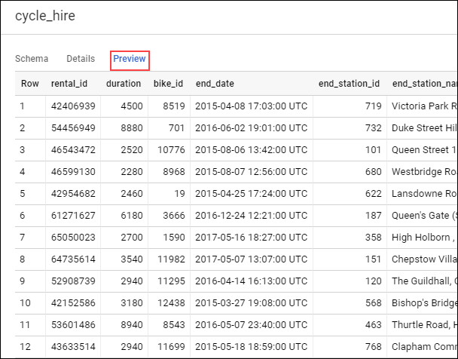

Inspect the columns and values populated in the rows. You are now ready to run some SQL queries on the cycle_hire table.

### **Running SELECT, FROM, and WHERE in BigQuery**

You now have a basic understanding of SQL querying keywords and the BigQuery data paradigm and some data to work with. Run some SQL commands using this service.

If you look at the bottom right corner of the console, you will notice that there are **24,369,201** rows of data, or individual bikeshare trips taken in London between 2015 and 2017 (not a small amount by any means!)

Now take note of the seventh column key: end_station_name, which specifies the end destination of bikeshare rides. Before we get too deep, let's first run a simple query to isolate the end_station_name column. Copy and paste the following command in to the Query editor:

SELECT end_station_name FROM `bigquery-public-data.london_bicycles.cycle_hire`;

content_copy

Then click **Run**.

After ~20 seconds, you should be returned with 24369201 rows that contain the single column you queried for: end_station_name.

Why don't you find out how many bike trips were 20 minutes or longer?

Click **COMPOSE NEW QUERY** to clear the Query editor, then run the following query that utilizes the WHERE keyword:

SELECT * FROM `bigquery-public-data.london_bicycles.cycle_hire` WHERE duration>=1200;

content_copy

This query may take a minute or so to run.

SELECT * returns all column values from the table. Duration is measured in seconds, which is why you used the value 1200 (60 * 20).

If you look in the bottom right corner you see that **7,334,890** rows were returned. As a fraction of the total (7334890/24369201), this means that ~30% of London bikeshare rides lasted 20 minutes or longer (they're in it for the long haul!)

### **Test your understanding**

The following are some multiple choice questions to reinforce your understanding of the concepts we've covered so far. Answer them to the best of your abilities.

A fully-managed petabyte-scale data warehouse that runs on the Google Cloud.



BigQuery



Cloud Storage bucket



Cloud SQL



Google Cloud

Submit

Projects contain datasets, and datasets contain tables.



True



False

Submit

With BigQuery, you can access datasets shared publicly from other Google Cloud projects.



True



False

Submit

## More SQL Keywords: GROUP BY, COUNT, AS, and ORDER BY

### **GROUP BY**

The GROUP BY keyword will aggregate result-set rows that share common criteria (e.g. a column value) and will return all of the unique entries found for such criteria.

This is a useful keyword for figuring out categorical information on tables. To get a better picture of what this keyword does, click **COMPOSE NEW QUERY**, then copy and paste the following command in the Query editor:

SELECT start_station_name FROM `bigquery-public-data.london_bicycles.cycle_hire` GROUP BY start_station_name;

content_copy

Click **Run**.

You should receive a similar output (row values may not match the following):

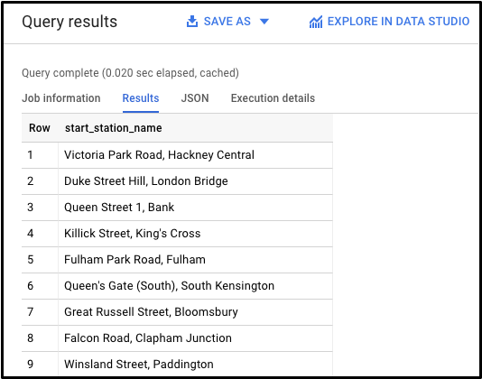

Without the GROUP BY, the query would have returned the full **24,369,201** rows. GROUP BY will output the unique (non-duplicate) column values found in the table. You can see this for yourself by looking in the bottom right corner. You will see **880** rows, meaning there are 880 distinct London bikeshare starting points.

### **COUNT**

The COUNT() function will return the number of rows that share the same criteria (e.g. column value). This can be very useful in tandem with a GROUP BY.

Add the COUNT function to our previous query to figure out how many rides begin in each starting point. Click **COMPOSE NEW QUERY**, copy and paste the following command in to the Query editor and then click **Run query**:

SELECT start_station_name, COUNT(*) FROM `bigquery-public-data.london_bicycles.cycle_hire` GROUP BY start_station_name;

content_copy

You should receive a similar output (row values may not match the following):

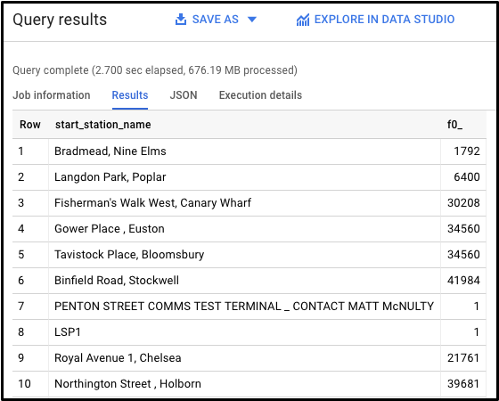

This shows how many bikeshare rides begin at each starting location.

### **AS**

SQL also has an AS keyword, which creates an alias of a table or column. An alias is a new name that's given to the returned column or table—whatever AS specifies.

Add an AS keyword to the last query we ran to see this in action. Click **COMPOSE NEW QUERY**, then copy and paste the following command in to the Query editor:

SELECT start_station_name, COUNT(*) AS num_starts FROM `bigquery-public-data.london_bicycles.cycle_hire` GROUP BY start_station_name;

content_copy

Click **Run**.

You should receive a similar output (be aware that the row values might not be identical):

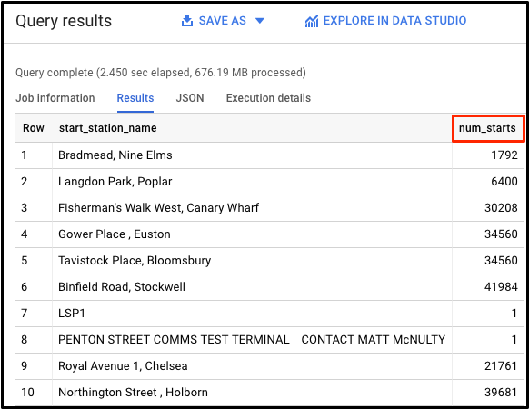

As you see, the COUNT(*) column in the returned table is now set to the alias name num_starts. This is a handy keyword to use especially if you are dealing with large sets of data — forgetting that an ambiguous table or column name happens more often than you think!

### **ORDER BY**

The ORDER BY keyword sorts the returned data from a query in ascending or descending order based on a specified criteria or column value. We will add this keyword to our previous query to do the following:

* Return a table that contains the number of bikeshare rides that begin in each starting station, organized alphabetically by the starting station.
* Return a table that contains the number of bikeshare rides that begin in each starting station, organized numerically from lowest to highest.
* Return a table that contains the number of bikeshare rides that begin in each starting station, organized numerically from highest to lowest.

Each of the commands below is a separate query. For each command, clear the Query editor, copy and paste the command in to the Query editor, and then click **Run**. Examine the results.

SELECT start_station_name, COUNT(*) AS num FROM `bigquery-public-data.london_bicycles.cycle_hire` GROUP BY start_station_name ORDER BY start_station_name;

content_copy

SELECT start_station_name, COUNT(*) AS num FROM `bigquery-public-data.london_bicycles.cycle_hire` GROUP BY start_station_name ORDER BY num;

content_copy

SELECT start_station_name, COUNT(*) AS num FROM `bigquery-public-data.london_bicycles.cycle_hire` GROUP BY start_station_name ORDER BY num DESC;

content_copy

The last query should have returned the following:

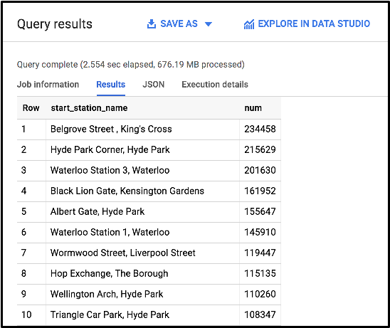

We see that "Belgrove Street, King's Cross" has the highest number of starts. However, as a fraction of the total (234458/24369201), we see that < 1% of rides start from this station.

### **Test your understanding**

The following are some multiple choice questions to reinforce your understanding of the concepts we've covered so far. Answer them to the best of your abilities.

Aggregates rows that share common criteria (e.g. a column value) and will return all of the unique entries found for such criteria.



COUNT



AS



GROUP BY



ORDER BY

Submit

A SQL function will count and return the number of rows that share common criteria.



GROUP BY



AS



COUNT



ORDER BY

Submit

Creates an alias of a table or column.



AS



GROUP BY



ORDER BY



COUNT

Submit

Sorts the returned data from a query in ascending or descending order based on a specified criteria or column value.



ORDER BY



GROUP BY



AS



COUNT

Submit

## Working with Cloud SQL

### **Exporting queries as CSV files**

[Cloud SQL](https://cloud.google.com/sql/) is a fully-managed database service that makes it easy to set up, maintain, manage, and administer your relational PostgreSQL and MySQL databases in the cloud. There are two formats of data accepted by Cloud SQL: dump files (.sql) or CSV files (.csv). You will learn how to export subsets of the cycle_hire table into CSV files and upload them to Cloud Storage as an intermediate location.

Back in the BigQuery Console, this should have been the last command that you ran:

SELECT start_station_name, COUNT(*) AS num FROM `bigquery-public-data.london_bicycles.cycle_hire` GROUP BY start_station_name ORDER BY num DESC;

content_copy

In the Query Results section click **SAVE RESULTS** > **CSV(local file)** > **SAVE**. This initiates a download, which saves this query as a CSV file. Note the location and the name of this downloaded file—you will need it soon.

Click **COMPOSE NEW QUERY**, then copy and run the following in the query editor:

SELECT end_station_name, COUNT(*) AS num FROM `bigquery-public-data.london_bicycles.cycle_hire` GROUP BY end_station_name ORDER BY num DESC;

content_copy

This will return a table that contains the number of bikeshare rides that finish in each ending station and is organized numerically from highest to lowest number of rides. You should receive the following output:

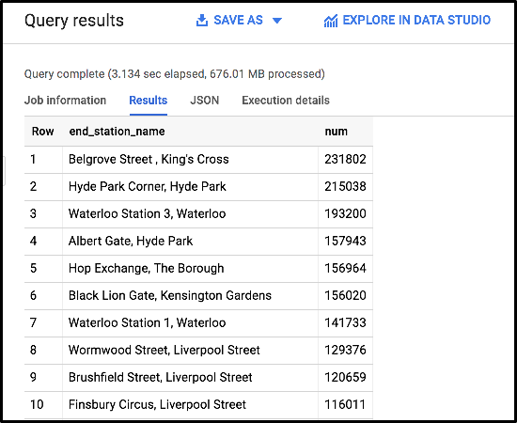

In the Query Results section click **SAVE RESULTS** > **CSV(local file)** > **SAVE**. This initiates a download, which saves this query as a CSV file. Note the location and the name of this downloaded file—you will need it in the following section.

### **Upload CSV files to Cloud Storage**

Go to the Cloud Console where you'll create a storage bucket where you can upload the files you just created.

Select **Navigation menu** > **Storage** > **Browser**, and then click **Create bucket**.

Enter a unique name for your bucket, keep all other settings, and hit **Create**:

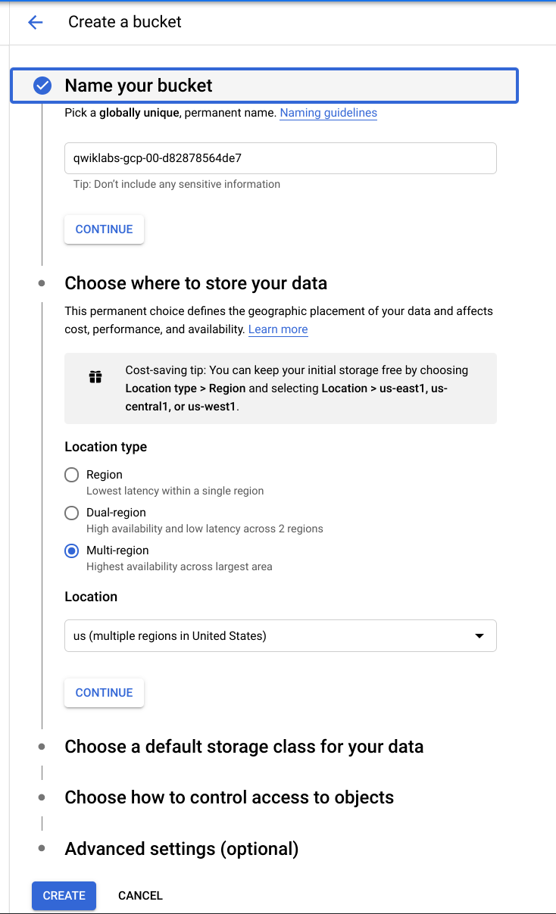

### **Test Completed Task**

Click **Check my progress** below to check your lab progress. If you successfully created your bucket, you'll see an assessment score.

Create a cloud storage bucket.

Check my progress

You should now be in the Cloud Console looking at your newly created Cloud Storage Bucket.

Click **Upload files** and select the CSV that contains start_station_name data. Then click **Open**. Repeat this for the end_station_name data.

Rename your start_station_name file by clicking on the three dots next to on the far side of the file and click **rename**. Rename the file start_station_data.csv.

Rename your end_station_name file by clicking on the three dots next to on the far side of the file and click **rename**. Rename the file end_station_data.csv.

Your bucket should now resemble the following:

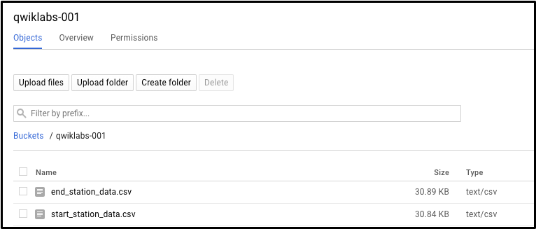

### **Test Completed Task**

Click **Check my progress** to verify your performed task. If you have successfully upload CSV objects to your bucket, you will see an assessment score.

Upload CSV files to Cloud Storage.

Check my progress

### **Create a Cloud SQL instance**

In the console, select **Navigation menu** > **SQL**.

Click **Create Instance**.

From here, you will be prompted to choose a database engine. Select **MySQL**.

Now enter in a name for your instance (like "qwiklabs-demo") and enter in a secure password in the **Root password** field (remember it!), then click **Create**:



It might take a few minutes for the instance to be created. Once it is, you will see a green checkmark next to the instance name.

Click on the Cloud SQL instance. You should now be on a page that resembles the following:

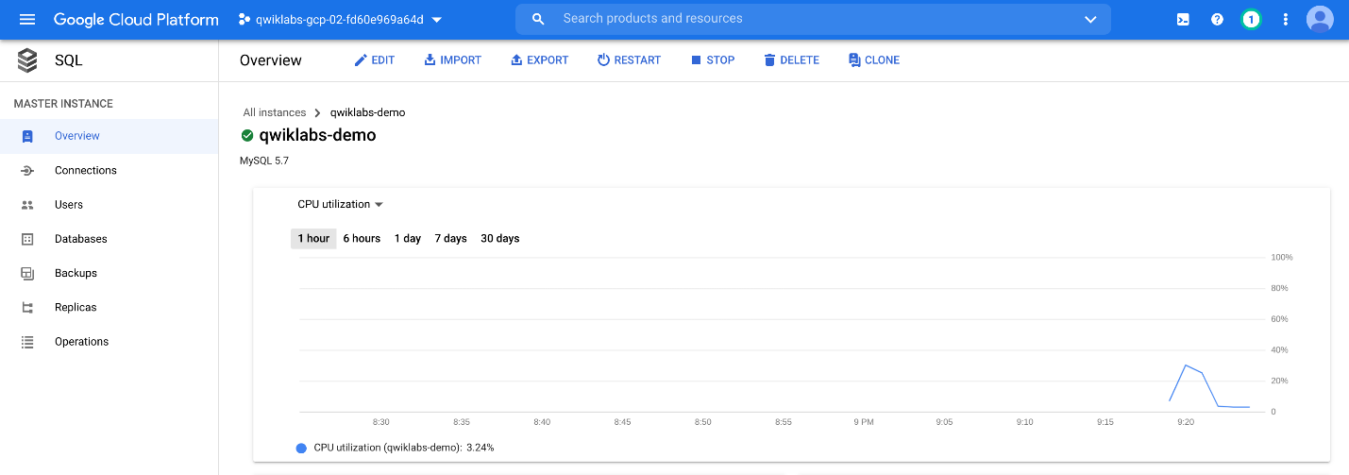

### **Test Completed Task**

To check out your lab progress, click **Check my progress** below.If you have successfully set up your Cloud SQL instance, you will see an assessment score.

Create a CloudSQL Instance.

Check my progress

## New Queries in Cloud SQL

### **CREATE keyword (databases and tables)**

Now that you have a Cloud SQL instance up and running, create a database inside of it using the Cloud Shell Command Line.

### **Activate Cloud Shell**

Cloud Shell is a virtual machine that is loaded with development tools. It offers a persistent 5GB home directory and runs on the Google Cloud. Cloud Shell provides command-line access to your Google Cloud resources.

In the Cloud Console, in the top right toolbar, click the **Activate Cloud Shell** button.

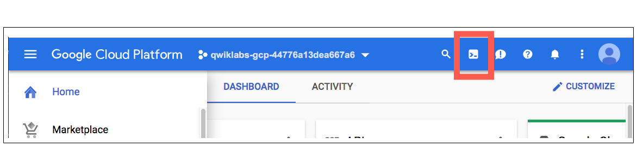

Click **Continue**.

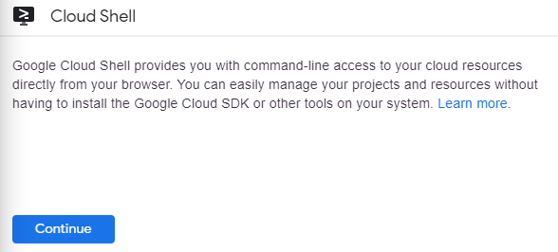

It takes a few moments to provision and connect to the environment. When you are connected, you are already authenticated, and the project is set to your PROJECT_ID. For example:

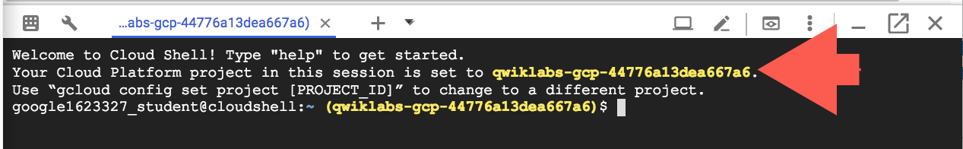

gcloud is the command-line tool for Google Cloud. It comes pre-installed on Cloud Shell and supports tab-completion.

You can list the active account name with this command:

gcloud auth list

content_copy

(Output)

Credentialed accounts:

- <myaccount>@<mydomain>.com (active)content_copy

(Example output)

Credentialed accounts:

- google1623327_student@qwiklabs.netcontent_copy

You can list the project ID with this command:

gcloud config list project

content_copy

(Output)

[core]

project = <project_ID>content_copy

(Example output)

[core]

project = qwiklabs-gcp-44776a13dea667a6content_copy

For full documentation of gcloud see the [gcloud command-line tool overview](https://cloud.google.com/sdk/gcloud).

Run the following command in Cloud Shell to connect to your SQL instance, replacing qwiklabs-demo if you used a different name for your instance:

gcloud sql connect qwiklabs-demo --user=root

content_copy

It may take a minute to connect to your instance.

When prompted, enter the root password you set for the instance.

You should now be on a similar output:

Welcome to the MySQL monitor. Commands end with ; or \g.

Your MySQL connection id is 494

Server version: 5.7.14-google-log (Google)

Copyright (c) 2000, 2017, Oracle, MariaDB Corporation Ab and others.

Type 'help;' or '\h' for help. Type '\c' to clear the current input statement.

MySQL [(none)]>

content_copy

A Cloud SQL instance comes with pre-configured databases, but you will create your own to store the London bikeshare data.

Run the following command at the MySQL server prompt to create a database called bike:

CREATE DATABASE bike;

content_copy

You should receive the following output:

Query OK, 1 row affected (0.05 sec)

MySQL [(none)]>

content_copy

### **Test Completed Task**

Check your progress by clicking **Check my progress** to verify your performed task. If you have successfully created database in Cloud SQL instance, you will see an assessment score.

Create a database.

Check my progress

Make a table inside of the bike database by running the following command:

USE bike;

CREATE TABLE london1 (start_station_name VARCHAR(255), num INT);

content_copy

This statement uses the CREATE keyword, but this time it uses the TABLE clause to specify that it wants to build a table instead of a database. The USE keyword specifies a database that you want to connect to. You now have a table named "london1" that contains two columns, "start_station_name" and "num". VARCHAR(255) specifies variable length string column that can hold up to 255 characters and INT is a column of type integer.

Create another table named "london2" by running the following command:

USE bike;

CREATE TABLE london2 (end_station_name VARCHAR(255), num INT);

content_copy

Now confirm that your empty tables were created. Run the following commands at the MySQL server prompt:

SELECT * FROM london1;

SELECT * FROM london2;

content_copy

You should receive the following output for both commands:

Empty set (0.04 sec)

content_copy

It says "empty set" because you haven't loaded in any data yet.

### **Upload CSV files to tables**

Return to the Cloud SQL console. You will now upload the start_station_name and end_station_name CSV files into your newly created london1 and london2 tables.

1. In your Cloud SQL instance page, click **IMPORT**.
2. In the Cloud Storage file field, click **Browse**, and then click the arrow opposite your bucket name, and then click start_station_data.csv. Click **Select**.
3. Select **CSV** as File format.
4. Select the bike database and type in "london1" as your table.
5. Click **Import**:



Do the same for the other CSV file.

1. In your Cloud SQL instance page, click **IMPORT**.
2. In the Cloud Storage file field, click **Browse**, and then click the arrow opposite your bucket name, and then click end_station_data.csv Click **Select**.
3. Select **CSV** as File format.
4. Select the bike database and type in "london2" as your table.
5. Click **Import**:

You should now have both CSV files uploaded to tables in the bike database.

Return to your Cloud Shell session and run the following command at the MySQL server prompt to inspect the contents of london1:

SELECT * FROM london1;

content_copy

You should receive 881 lines of output, one more each unique station name. Your output be formatted like this:

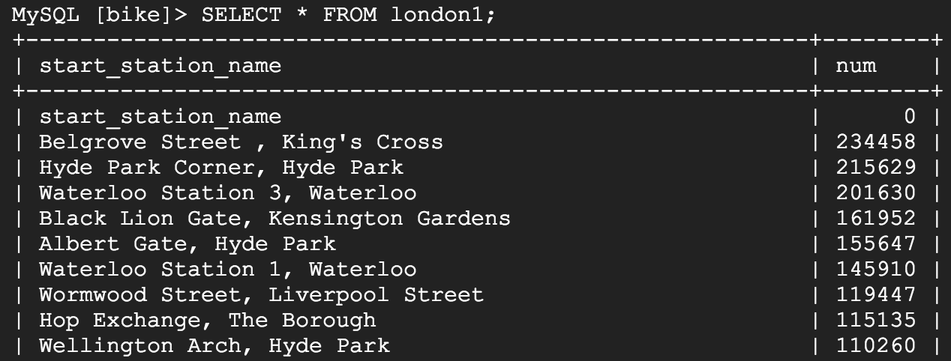

Run the following command to make sure that london2 has been populated:

SELECT * FROM london2;

content_copy

You should receive 883 lines of output, one more each unique station name. Your output be formatted like this:

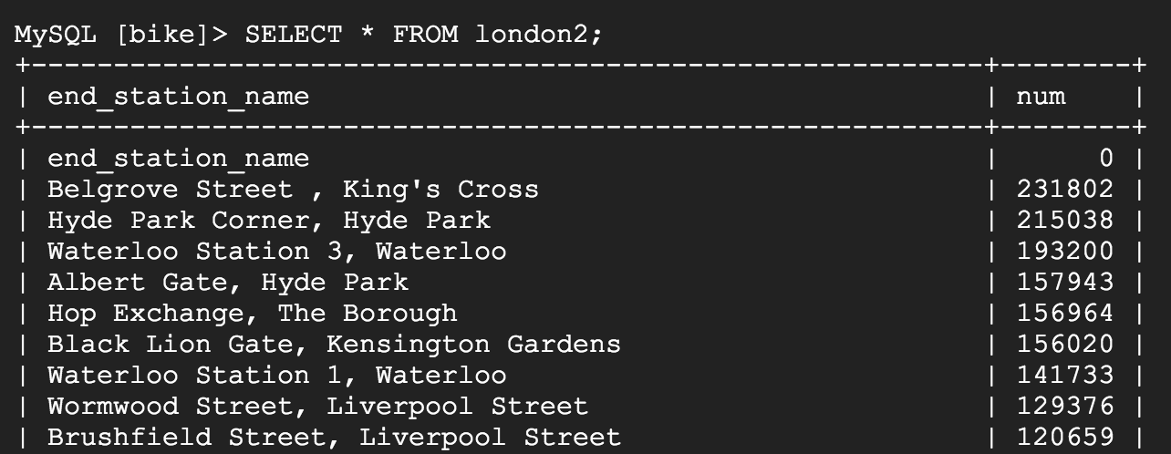

### **DELETE keyword**

Here are a couple more SQL keywords that help us with data management. The first is the DELETE keyword.

Run the following commands in your MySQL session to delete the first row of the london1 and london2:

DELETE FROM london1 WHERE num=0;

DELETE FROM london2 WHERE num=0;

content_copy

You should receive the following output after running both commands:

Query OK, 1 row affected (0.04 sec)

content_copy

The rows deleted were the column headers from the CSV files. The DELETE keyword will not remove the first row of the file per se, but all rows of the table where the column name (in this case "num") contains a specified value (in this case "0"). If you run the SELECT * FROM london1; and SELECT * FROM london2; queries and scroll to the top of the table, you will see that those rows no longer exist.

### **INSERT INTO keyword**

You can also insert values into tables with the INSERT INTO keyword. Run the following command to insert a new row into london1, which sets start_station_name to "test destination" and num to "1":

INSERT INTO london1 (start_station_name, num) VALUES ("test destination", 1);

content_copy

The INSERT INTO keyword requires a table (london1) and will create a new row with columns specified by the terms in the first parenthesis (in this case "start_station_name" and "num"). Whatever comes after the "VALUES" clause will be inserted as values in the new row.

You should receive the following output:

Query OK, 1 row affected (0.05 sec)

content_copy

If you run the query SELECT * FROM london1; you will see an additional row added at the bottom of the "london1" table:

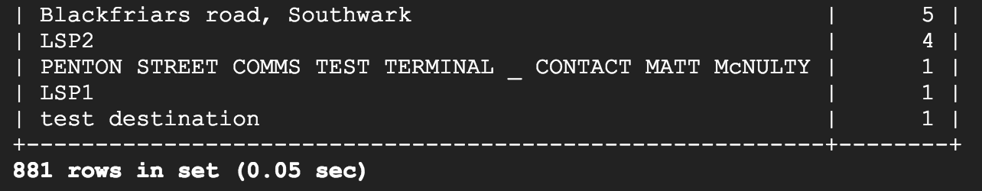

### **UNION keyword**

The last SQL keyword that you'll learn about is UNION. This keyword combines the output of two or more SELECT queries into a result-set. You use UNION to combine subsets of the "london1" and "london2" tables.

The following chained query pulls specific data from both tables and combine them with the UNION operator.

Run the following command at the MySQL server prompt:

SELECT start_station_name AS top_stations, num FROM london1 WHERE num>100000

UNION

SELECT end_station_name, num FROM london2 WHERE num>100000

ORDER BY top_stations DESC;

content_copy

The first SELECT query selects the two columns from the "london1" table and creates an alias for "start_station_name", which gets set to "top_stations". It uses the WHERE keyword to only pull rideshare station names where over 100,000 bikes start their journey.

The second SELECT query selects the two columns from the "london2" table and uses the WHERE keyword to only pull rideshare station names where over 100,000 bikes end their journey.

The UNION keyword in between combines the output of these queries by assimilating the "london2" data with "london1". Since "london1" is being unioned with "london2", the column values that take precedent are "top_stations" and "num".

ORDER BY will order the final, unioned table by the "top_stations" column value alphabetically and in descending order.

You should receive the following output:

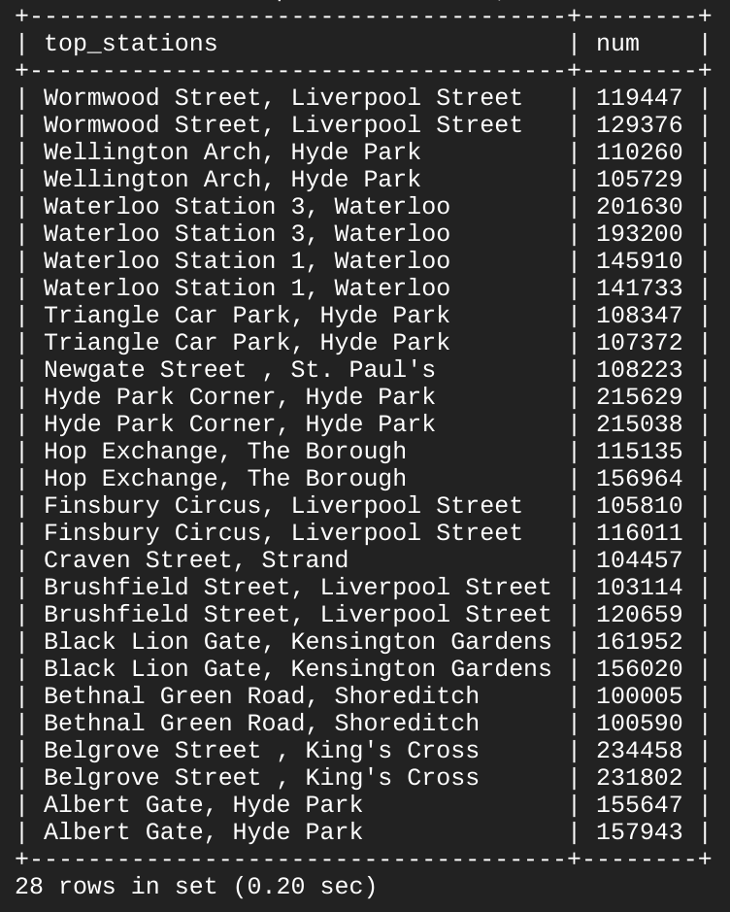

As you see, 13/14 stations share the top spots for rideshare starting and ending points. With some basic SQL keywords you were able to query a sizable dataset, which returned data points and answers to specific questions.

Lab 3:

# Multiple VPC Networks

1 hour 10 minutesFree

Rate Lab

## GSP211



## Overview

In this lab you create several VPC networks and VM instances and test connectivity across networks. Specifically, you create two custom mode networks (**managementnet** and **privatenet**) with firewall rules and VM instances as shown in this network diagram:

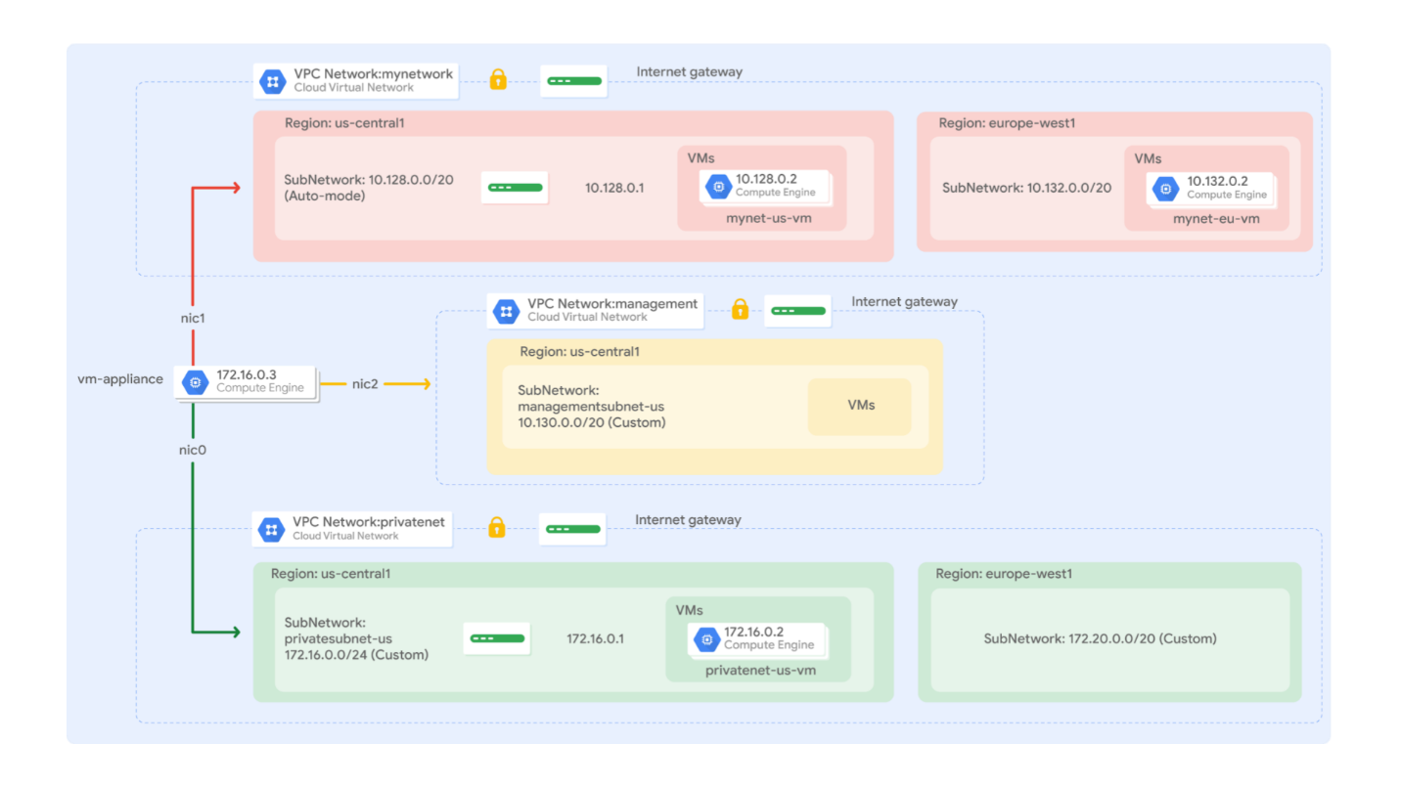

The **mynetwork** network with its firewall rules and two VM instances (**mynet-eu-vm** and **mynet-us-vm**) have already been created for you in this Qwiklabs project.

### **Objectives**

In this lab, you will learn how to perform the following tasks:

* Create custom mode VPC networks with firewall rules
* Create VM instances using Compute Engine
* Explore the connectivity for VM instances across VPC networks
* Create a VM instance with multiple network interfaces

## Setup and Requirements

#### Before you click the Start Lab button

Read these instructions. Labs are timed and you cannot pause them. The timer, which starts when you click **Start Lab**, shows how long Google Cloud resources will be made available to you.

This Qwiklabs hands-on lab lets you do the lab activities yourself in a real cloud environment, not in a simulation or demo environment. It does so by giving you new, temporary credentials that you use to sign in and access Google Cloud for the duration of the lab.

#### What you need

To complete this lab, you need:

* Access to a standard internet browser (Chrome browser recommended).
* Time to complete the lab.

**Note:** If you already have your own personal Google Cloud account or project, do not use it for this lab.

**Note:** If you are using a Pixelbook, open an Incognito window to run this lab.

#### How to start your lab and sign in to the Google Cloud Console

1. Click the **Start Lab** button. If you need to pay for the lab, a pop-up opens for you to select your payment method. On the left is a panel populated with the temporary credentials that you must use for this lab.



1. Copy the username, and then click **Open Google Console**. The lab spins up resources, and then opens another tab that shows the **Sign in** page.



**Tip:** Open the tabs in separate windows, side-by-side.

If you see the **Choose an account** page, click **Use Another Account**. 

1. In the **Sign in** page, paste the username that you copied from the Connection Details panel. Then copy and paste the password.

**Important:** You must use the credentials from the Connection Details panel. Do not use your Qwiklabs credentials. If you have your own Google Cloud account, do not use it for this lab (avoids incurring charges).

1. Click through the subsequent pages:
   * Accept the terms and conditions.
   * Do not add recovery options or two-factor authentication (because this is a temporary account).
   * Do not sign up for free trials.

After a few moments, the Cloud Console opens in this tab.

**Note:** You can view the menu with a list of Google Cloud Products and Services by clicking the **Navigation menu** at the top-left. 

### **Activate Cloud Shell**

Cloud Shell is a virtual machine that is loaded with development tools. It offers a persistent 5GB home directory and runs on the Google Cloud. Cloud Shell provides command-line access to your Google Cloud resources.

In the Cloud Console, in the top right toolbar, click the **Activate Cloud Shell** button.



Click **Continue**.



It takes a few moments to provision and connect to the environment. When you are connected, you are already authenticated, and the project is set to your PROJECT_ID. For example:



gcloud is the command-line tool for Google Cloud. It comes pre-installed on Cloud Shell and supports tab-completion.

You can list the active account name with this command:

gcloud auth list

content_copy

(Output)

Credentialed accounts:

- <myaccount>@<mydomain>.com (active)content_copy

(Example output)

Credentialed accounts:

- google1623327_student@qwiklabs.netcontent_copy

You can list the project ID with this command:

gcloud config list project

content_copy

(Output)

[core]

project = <project_ID>content_copy

(Example output)

[core]

project = qwiklabs-gcp-44776a13dea667a6content_copy

For full documentation of gcloud see the [gcloud command-line tool overview](https://cloud.google.com/sdk/gcloud).

## Create custom mode VPC networks with firewall rules

Create two custom networks **managementnet** and **privatenet**, along with firewall rules to allow **SSH**, **ICMP**, and **RDP** ingress traffic.

### **Create the managementnet network**

Create the **managementnet** network using the Cloud Console.

1. In the Cloud Console, navigate to **Navigation menu** () > **VPC network** > **VPC networks**.

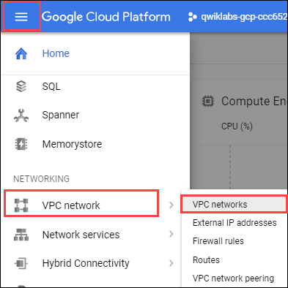

1. Notice the **default** and **mynetwork** networks with their subnets.

Each Google Cloud project starts with the **default** network. In addition, the **mynetwork** network has been premade as part of your network diagram.

1. Click **Create VPC Network**.
2. Set the **Name** to managementnet.
3. For **Subnet creation mode**, click **Custom**.
4. Set the following values, leave all other values at their defaults:

|  |  |
| --- | --- |
| **Property** | **Value (type value or select option as specified)** |
| Name | managementsubnet-us |
| Region | us-central1 |
| IP address range | 10.130.0.0/20 |

1. Click **Done**.
2. Click **command line**.

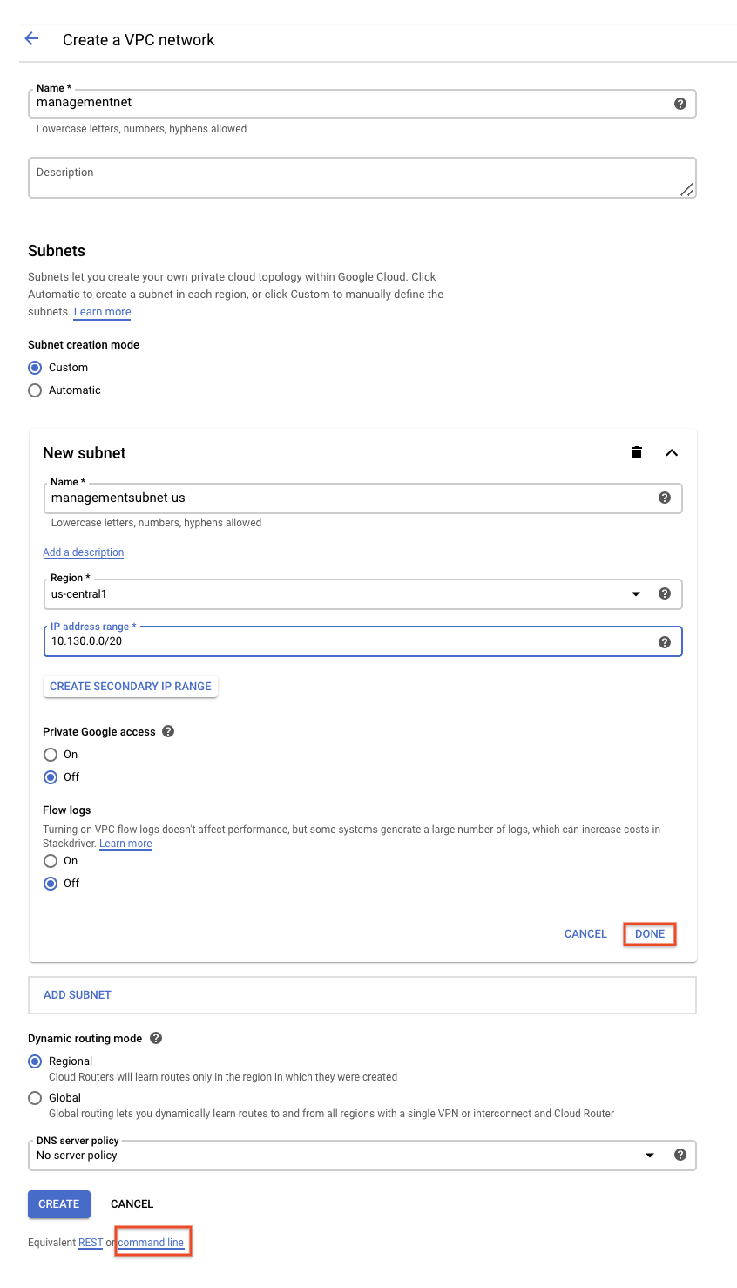

These commands illustrate that networks and subnets can be created using the Cloud Shell command line. You will create the **privatenet** network using these commands with similar parameters.

1. Click **Close**.
2. Click **Create**.

#### Test Completed Task

Click **Check my progress** to verify your performed task. If you have successfully created a managementnet network, you will see an assessment score.

Create the managementnet network

Check my progress

### **Create the privatenet network**

Create the **privatenet** network using the Cloud Shell command line.

1. Run the following command to create the **privatenet** network:

gcloud compute networks create privatenet --subnet-mode=custom

content_copy

1. Run the following command to create the **privatesubnet-us** subnet:

gcloud compute networks subnets create privatesubnet-us --network=privatenet 172.16.0.0/24

content_copy

1. Run the following command to create the **privatesubnet-eu** subnet:

gcloud compute networks subnets create privatesubnet-eu --network=privatenet --region=europe-west1 --range=172.20.0.0/20

content_copy

#### Test Completed Task

Click **Check my progress** to verify your performed task. If you have successfully created a privatenet network, you will see an assessment score.

Create the privatenet network

Check my progress

1. Run the following command to list the available VPC networks:

gcloud compute networks list

content_copy

The output should look like this (**do not copy; this is example output**):

NAME SUBNET_MODE BGP_ROUTING_MODE IPV4_RANGE GATEWAY_IPV4

default AUTO REGIONAL

managementnet CUSTOM REGIONAL

mynetwork AUTO REGIONAL

privatenet CUSTOM REGIONAL

content_copy

**default** and **mynetwork** are auto mode networks, whereas, **managementnet** and **privatenet** are custom mode networks. Auto mode networks create subnets in each region automatically, while custom mode networks start with no subnets, giving you full control over subnet creation

1. Run the following command to list the available VPC subnets (sorted by VPC network):

gcloud compute networks subnets list --sort-by=NETWORK

content_copy

The output should look like this (**do not copy; this is example output**):

NAME REGION NETWORK RANGE

default asia-northeast1 default 10.146.0.0/20

default us-west1 default 10.138.0.0/20

default southamerica-east1 default 10.158.0.0/20

default europe-west4 default 10.164.0.0/20

default asia-east1 default 10.140.0.0/20

default europe-north1 default 10.166.0.0/20

default asia-southeast1 default 10.148.0.0/20

default us-east4 default 10.150.0.0/20

default europe-west1 default 10.132.0.0/20

default europe-west2 default 10.154.0.0/20

default europe-west3 default 10.156.0.0/20

default australia-southeast1 default 10.152.0.0/20

default asia-south1 default 10.160.0.0/20

default us-east1 default 10.142.0.0/20

default us-central1 default 10.128.0.0/20

default northamerica-northeast1 default 10.162.0.0/20

managementsubnet-us us-central1 managementnet 10.130.0.0/20

mynetwork asia-northeast1 mynetwork 10.146.0.0/20

mynetwork us-west1 mynetwork 10.138.0.0/20

mynetwork southamerica-east1 mynetwork 10.158.0.0/20

mynetwork europe-west4 mynetwork 10.164.0.0/20

mynetwork asia-east1 mynetwork 10.140.0.0/20

mynetwork europe-north1 mynetwork 10.166.0.0/20

mynetwork asia-southeast1 mynetwork 10.148.0.0/20

mynetwork us-east4 mynetwork 10.150.0.0/20

mynetwork europe-west1 mynetwork 10.132.0.0/20

mynetwork europe-west2 mynetwork 10.154.0.0/20

mynetwork europe-west3 mynetwork 10.156.0.0/20

mynetwork australia-southeast1 mynetwork 10.152.0.0/20

mynetwork asia-south1 mynetwork 10.160.0.0/20

mynetwork us-east1 mynetwork 10.142.0.0/20

mynetwork us-central1 mynetwork 10.128.0.0/20

mynetwork northamerica-northeast1 mynetwork 10.162.0.0/20

privatesubnet-eu europe-west1 privatenet 172.20.0.0/20

privatesubnet-us us-central1 privatenet 172.16.0.0/24

content_copy

As expected, the **default** and **mynetwork** networks have subnets in [each region](https://cloud.google.com/compute/docs/regions-zones/#available) as they are auto mode networks. The **managementnet** and **privatenet** networks only have the subnets that you created as they are custom mode networks.

1. In the Cloud Console, navigate to **Navigation menu** > **VPC network** > **VPC networks**.
2. You see that the same networks and subnets are listed in the Cloud Console.

### **Create the firewall rules for managementnet**

Create firewall rules to allow **SSH**, **ICMP**, and **RDP** ingress traffic to VM instances on the **managementnet** network.

1. In the Cloud Console, navigate to **Navigation menu** () > **VPC network** > **Firewall**.
2. Click **+ Create Firewall Rule**.
3. Set the following values, leave all other values at their defaults:

|  |  |
| --- | --- |
| **Property** | **Value (type value or select option as specified)** |
| Name | managementnet-allow-icmp-ssh-rdp |
| Network | managementnet |
| Targets | All instances in the network |
| Source filter | IP Ranges |
| Source IP ranges | 0.0.0.0/0 |
| Protocols and ports | Specified protocols and ports, and then check tcp, type: 22, 3389; and check Other protocols, type: icmp. |

Make sure to include the **/0** in the **Source IP ranges** to specify all networks.

1. Click **command line**.

These commands illustrate that firewall rules can also be created using the Cloud Shell command line. You will create the **privatenet**'s firewall rules using these commands with similar parameters.

1. Click **Close**.
2. Click **Create**.

#### Test Completed Task

Click **Check my progress** to verify your performed task. If you have successfully created firewall rules for managementnet network, you will see an assessment score.

Create the firewall rules for managementnet

Check my progress

### **Create the firewall rules for privatenet**

Create the firewall rules for **privatenet** network using the Cloud Shell command line.

1. In Cloud Shell, run the following command to create the **privatenet-allow-icmp-ssh-rdp** firewall rule:

gcloud compute firewall-rules create privatenet-allow-icmp-ssh-rdp --direction=INGRESS --priority=1000 --network=privatenet --action=ALLOW --rules=icmp,tcp:22,tcp:3389 --source-ranges=0.0.0.0/0

content_copy

The output should look like this (**do not copy; this is example output**):

NAME NETWORK DIRECTION PRIORITY ALLOW DENY

privatenet-allow-icmp-ssh-rdp privatenet INGRESS 1000 icmp,tcp:22,tcp:3389

content_copy

#### Test Completed Task

Click **Check my progress** to verify your performed task. If you have successfully created firewall rules for privatenet network, you will see an assessment score.

Create the firewall rules for privatenet

Check my progress

1. Run the following command to list all the firewall rules (sorted by VPC network):

gcloud compute firewall-rules list --sort-by=NETWORK

content_copy

The output should look like this (**do not copy; this is example output**):

NAME NETWORK DIRECTION PRIORITY ALLOW DENY

default-allow-icmp default INGRESS 65534 icmp

default-allow-internal default INGRESS 65534 tcp:0-65535,udp:0-65535,icmp

default-allow-rdp default INGRESS 65534 tcp:3389

default-allow-ssh default INGRESS 65534 tcp:22

managementnet-allow-icmp-ssh-rdp managementnet INGRESS 1000 icmp,tcp:22,tcp:3389

mynetwork-allow-icmp mynetwork INGRESS 1000 icmp

mynetwork-allow-rdp mynetwork INGRESS 1000 tcp:3389

mynetwork-allow-ssh mynetwork INGRESS 1000 tcp:22

privatenet-allow-icmp-ssh-rdp privatenet INGRESS 1000 icmp,tcp:22,tcp:3389

content_copy

The firewall rules for **mynetwork** network have been created for you. You can define multiple protocols and ports in one firewall rule (**privatenet** and **managementnet**), or spread them across multiple rules (**default** and **mynetwork**).

1. In the Cloud Console, navigate to **Navigation menu** > **VPC network** > **Firewall**.
2. You see that the same firewall rules are listed in the Cloud Console.

## Create VM instances

Create two VM instances:

* **managementnet-us-vm** in **managementsubnet-us**
* **privatenet-us-vm** in **privatesubnet-us**

### **Create the managementnet-us-vm instance**

Create the **managementnet-us-vm** instance using the Cloud Console.

1. In the Cloud Console, navigate to **Navigation menu** > **Compute Engine** > **VM instances**.

The **mynet-eu-vm** and **mynet-us-vm** has been created for you, as part of your network diagram.

1. Click **Create instance**.
2. Set the following values, leave all other values at their defaults:

|  |  |
| --- | --- |
| **Property** | **Value (type value or select option as specified)** |
| Name | managementnet-us-vm |
| Region | us-central1 |
| Zone | us-central1-c |
| Series | N1 |
| Machine type | 1 vCPU (f1-micro) |

1. Click **Management, security, disks, networking, sole tenancy**.
2. Click **Networking**.
3. For **Network interfaces**, click the pencil icon to edit.
4. Set the following values, leave all other values at their defaults:

|  |  |
| --- | --- |
| **Property** | **Value (type value or select option as specified)** |
| Network | managementnet |
| Subnetwork | managementsubnet-us |

1. Click **Done**.
2. Click **command line**.

This illustrate that VM instances can also be created using the Cloud Shell command line. You will create the **privatenet-us-vm** instance using these commands with similar parameters.

1. Click **Close**.
2. Click **Create**.

#### Test Completed Task

Click **Check my progress** to verify your performed task. If you have successfully created VM instance in managementnet network, you will see an assessment score.

Create the managementnet-us-vm instance

Check my progress

### **Create the privatenet-us-vm instance**

Create the **privatenet-us-vm** instance using the Cloud Shell command line.

1. In Cloud Shell, run the following command to create the **privatenet-us-vm** instance:

gcloud compute instances create privatenet-us-vm --zone=us-central1-c --machine-type=n1-standard-1 --subnet=privatesubnet-us

content_copy

The output should look like this (**do not copy; this is example output**):

NAME ZONE MACHINE_TYPE PREEMPTIBLE INTERNAL_IP EXTERNAL_IP STATUS

privatenet-us-vm us-central1-c n1-standard-1 172.16.0.2 35.184.221.40 RUNNING

content_copy

#### Test Completed Task

Click **Check my progress** to verify your performed task. If you have successfully created VM instance in privatenet network, you will see an assessment score.

Create the privatenet-us-vm instance

Check my progress

1. Run the following command to list all the VM instances (sorted by zone):

gcloud compute instances list --sort-by=ZONE

content_copy

The output should look like this (**do not copy; this is example output**):

NAME ZONE MACHINE_TYPE PREEMPTIBLE INTERNAL_IP EXTERNAL_IP STATUS

mynet-eu-vm europe-west1-c n1-standard-1 10.132.0.2 35.205.124.164 RUNNING

managementnet-us-vm us-central1-c n1-standard-1 10.130.0.2 35.226.20.87 RUNNING

mynet-us-vm us-central1-c n1-standard-1 10.128.0.2 35.232.252.86 RUNNING

privatenet-us-vm us-central1-c n1-standard-1 172.16.0.2 35.184.221.40 RUNNING

content_copy

1. In the Cloud Console, navigate to **Navigation menu** () > **Compute Engine** > **VM instances**.
2. You see that the VM instances are listed in the Cloud Console.
3. Click on **Columns**, then select **Network**.

There are three instances in **us-central1-c** and one instance in **europe-west1-c**. However, these instances are spread across three VPC networks (**managementnet**, **mynetwork** and **privatenet**), with no instance in the same zone and network as another. In the next section, you explore the effect this has on internal connectivity.

## Explore the connectivity between VM instances

Explore the connectivity between the VM instances. Specifically, determine the effect of having VM instances in the same zone versus having instances in the same VPC network.

### **Ping the external IP addresses**

Ping the external IP addresses of the VM instances to determine if you can reach the instances from the public internet.

1. In the Cloud Console, navigate to **Navigation menu** > **Compute Engine** > **VM instances**.
2. Note the external IP addressees for **mynet-eu-vm**, **managementnet-us-vm**, and **privatenet-us-vm**.
3. For **mynet-us-vm**, click **SSH** to launch a terminal and connect.
4. To test connectivity to **mynet-eu-vm**'s external IP, run the following command, replacing **mynet-eu-vm**'s external IP:

ping -c 3 <Enter mynet-eu-vm's external IP here>

content_copy

This should work!

1. To test connectivity to **managementnet-us-vm**'s external IP, run the following command, replacing **managementnet-us-vm**'s external IP:

ping -c 3 <Enter managementnet-us-vm's external IP here>

content_copy

This should work!

1. To test connectivity to **privatenet-us-vm**'s external IP, run the following command, replacing **privatenet-us-vm**'s external IP:

ping -c 3 <Enter privatenet-us-vm's external IP here>

content_copy

This should work!

You are able to ping the external IP address of all VM instances, even though they are either in a different zone or VPC network. This confirms public access to those instances is only controlled by the **ICMP** firewall rules that you established earlier.

### **Ping the internal IP addresses**

Ping the internal IP addresses of the VM instances to determine if you can reach the instances from within a VPC network.

1. In the Cloud Console, navigate to **Navigation menu** > **Compute Engine** > **VM instances**.
2. Note the internal IP addressees for **mynet-eu-vm**, **managementnet-us-vm**, and **privatenet-us-vm**.
3. Return to the **SSH** terminal for **mynet-us-vm**.
4. To test connectivity to **mynet-eu-vm**'s internal IP, run the following command, replacing **mynet-eu-vm**'s internal IP:

ping -c 3 <Enter mynet-eu-vm's internal IP here>

content_copy

You are able to ping the internal IP address of **mynet-eu-vm** because it is on the same VPC network as the source of the ping (**mynet-us-vm**), even though both VM instances are in separate zones, regions and continents!

1. To test connectivity to **managementnet-us-vm**'s internal IP, run the following command, replacing **managementnet-us-vm**'s internal IP:

ping -c 3 <Enter managementnet-us-vm's internal IP here>

content_copy

This should not work as indicated by a 100% packet loss!

1. To test connectivity to **privatenet-us-vm**'s internal IP, run the following command, replacing **privatenet-us-vm**'s internal IP:

ping -c 3 <Enter privatenet-us-vm's internal IP here>

content_copy

This should not work either as indicated by a 100% packet loss! You are unable to ping the internal IP address of **managementnet-us-vm** and **privatenet-us-vm** because they are in separate VPC networks from the source of the ping (**mynet-us-vm**), even though they are all in the same zone **us-central1**.

VPC networks are by default isolated private networking domains. However, no internal IP address communication is allowed between networks, unless you set up mechanisms such as VPC peering or VPN.

Which instance(s) should you be able to ping from mynet-us-vm using internal IP addresses?



managementnet-us-vm



privatenet-us-vm



mynet-eu-vm

Submit

## Create a VM instance with multiple network interfaces

Every instance in a VPC network has a default network interface. You can create additional network interfaces attached to your VMs. Multiple network interfaces enable you to create configurations in which an instance connects directly to several VPC networks (up to 8 interfaces, depending on the instance's type).

### **Create the VM instance with multiple network interfaces**

Create the **vm-appliance** instance with network interfaces in **privatesubnet-us**, **managementsubnet-us** and **mynetwork**. The CIDR ranges of these subnets do not overlap, which is a requirement for creating a VM with multiple network interface controllers (NICs).

1. In the Cloud Console, navigate to **Navigation menu** > **Compute Engine** > **VM instances**.
2. Click **Create instance**.
3. Set the following values, leave all other values at their defaults:

|  |  |
| --- | --- |
| **Property** | **Value (type value or select option as specified)** |
| Name | vm-appliance |
| Region | us-central1 |
| Zone | us-central1-c |
| Series | N1 |
| Machine type | 4 vCPUs (n1-standard-4) |

The number of interfaces allowed in an instance is dependent on the instance's machine type and the number of vCPUs. The n1-standard-4 allows up to 4 network interfaces. Refer [here](https://cloud.google.com/vpc/docs/create-use-multiple-interfaces#max-interfaces) for more information.

1. Click **Management, security, disks, networking, sole tenancy**.
2. Click **Networking**.
3. For **Network interfaces**, click the pencil icon to edit.
4. Set the following values, leave all other values at their defaults:

|  |  |
| --- | --- |
| **Property** | **Value (type value or select option as specified)** |
| Network | privatenet |
| Subnetwork | privatesubnet-us |

1. Click **Done**.
2. Click **Add network interface**.
3. Set the following values, leave all other values at their defaults:

|  |  |
| --- | --- |
| **Property** | **Value (type value or select option as specified)** |
| Network | managementnet |
| Subnetwork | managementsubnet-us |

1. Click **Done**.
2. Click **Add network interface**.
3. Set the following values, leave all other values at their defaults:

|  |  |
| --- | --- |
| **Property** | **Value (type value or select option as specified)** |
| Network | mynetwork |
| Subnetwork | mynetwork |

1. Click **Done**.
2. Click **Create**.

#### Test Completed Task

Click **Check my progress** to verify your performed task. If you have successfully created VM instance with multiple network interfaces, you will see an assessment score.

Create a VM instance with multiple network interfaces

Check my progress

### **Explore the network interface details**

Explore the network interface details of **vm-appliance** within the Cloud Console and within the VM's terminal.

1. In the Cloud Console, navigate to **Navigation menu** () > **Compute Engine** > **VM instances**.
2. Click **nic0** within the **Internal IP** address of **vm-appliance** to open the **Network interface details** page.
3. Verify that **nic0** is attached to **privatesubnet-us**, is assigned an internal IP address within that subnet (172.16.0.0/24), and has applicable firewall rules.
4. Click **nic0** and select **nic1**.
5. Verify that **nic1** is attached to **managementsubnet-us**, is assigned an internal IP address within that subnet (10.130.0.0/20), and has applicable firewall rules.
6. Click **nic1** and select **nic2**.
7. Verify that **nic2** is attached to **mynetwork**, is assigned an internal IP address within that subnet (10.128.0.0/20), and has applicable firewall rules.

Each network interface has its own internal IP address so that the VM instance can communicate with those networks.

1. In the Cloud Console, navigate to **Navigation menu** > **Compute Engine** > **VM instances**.
2. For **vm-appliance**, click **SSH** to launch a terminal and connect.
3. Run the following, to list the network interfaces within the VM instance:

sudo ifconfig

content_copy

The output should look like this (**do not copy; this is example output**):

eth0: flags=4163<UP,BROADCAST,RUNNING,MULTICAST> mtu 1460

inet 172.16.0.3 netmask 255.255.255.255 broadcast 172.16.0.3

inet6 fe80::4001:acff:fe10:3 prefixlen 64 scopeid 0x20<link>

ether 42:01:ac:10:00:03 txqueuelen 1000 (Ethernet)

RX packets 626 bytes 171556 (167.5 KiB)

RX errors 0 dropped 0 overruns 0 frame 0

TX packets 568 bytes 62294 (60.8 KiB)

TX errors 0 dropped 0 overruns 0 carrier 0 collisions 0

eth1: flags=4163<UP,BROADCAST,RUNNING,MULTICAST> mtu 1460

inet 10.130.0.3 netmask 255.255.255.255 broadcast 10.130.0.3

inet6 fe80::4001:aff:fe82:3 prefixlen 64 scopeid 0x20<link>

ether 42:01:0a:82:00:03 txqueuelen 1000 (Ethernet)

RX packets 7 bytes 1222 (1.1 KiB)

RX errors 0 dropped 0 overruns 0 frame 0

TX packets 17 bytes 1842 (1.7 KiB)

TX errors 0 dropped 0 overruns 0 carrier 0 collisions 0

eth2: flags=4163<UP,BROADCAST,RUNNING,MULTICAST> mtu 1460

inet 10.128.0.3 netmask 255.255.255.255 broadcast 10.128.0.3

inet6 fe80::4001:aff:fe80:3 prefixlen 64 scopeid 0x20<link>

ether 42:01:0a:80:00:03 txqueuelen 1000 (Ethernet)

RX packets 17 bytes 2014 (1.9 KiB)

RX errors 0 dropped 0 overruns 0 frame 0

TX packets 17 bytes 1862 (1.8 KiB)

TX errors 0 dropped 0 overruns 0 carrier 0 collisions 0

content_copy

The **sudo ifconfig** command lists a Linux VM's network interfaces along with the internal IP addresses for each interface.

### **Explore the network interface connectivity**

Demonstrate that the **vm-appliance** instance is connected to **privatesubnet-us**, **managementsubnet-us** and **mynetwork** by pinging VM instances on those subnets.

1. In the Cloud Console, navigate to **Navigation menu** > **Compute Engine** > **VM instances**.
2. Note the internal IP addressees for **privatenet-us-vm**, **managementnet-us-vm**, **mynet-us-vm**, and **mynet-eu-vm**.
3. Return to the **SSH** terminal for **vm-appliance**.
4. To test connectivity to **privatenet-us-vm**'s internal IP, run the following command, replacing **privatenet-us-vm**'s internal IP:

ping -c 3 <Enter privatenet-us-vm's internal IP here>

content_copy

This works!

1. Repeat the same test by running the following:

ping -c 3 privatenet-us-vm

content_copy

You are able to ping **privatenet-us-vm** by its name because VPC networks have an internal DNS service that allows you to address instances by their DNS names rather than their internal IP addresses. When an internal DNS query is made with the instance hostname, it resolves to the primary interface (nic0) of the instance. Therefore, this only works for **privatenet-us-vm** in this case.

1. To test connectivity to **managementnet-us-vm**'s internal IP, run the following command, replacing **managementnet-us-vm**'s internal IP:

ping -c 3 <Enter managementnet-us-vm's internal IP here>

content_copy

This works!

1. To test connectivity to **mynet-us-vm**'s internal IP, run the following command, replacing **mynet-us-vm**'s internal IP:

ping -c 3 <Enter mynet-us-vm's internal IP here>

content_copy

This works!

1. To test connectivity to **mynet-eu-vm**'s internal IP, run the following command, replacing **mynet-eu-vm**'s internal IP:

ping -c 3 <Enter mynet-eu-vm's internal IP here>

content_copy

This does not work! In a multiple interface instance, every interface gets a route for the subnet that it is in. In addition, the instance gets a single default route that is associated with the primary interface eth0. Unless manually configured otherwise, any traffic leaving an instance for any destination other than a directly connected subnet will leave the instance via the default route on eth0.

1. To list the routes for **vm-appliance** instance, run the following command:

ip route

content_copy

The output should look like this (**do not copy; this is example output**):

default via 172.16.0.1 dev eth0

10.128.0.0/20 via 10.128.0.1 dev eth2

10.128.0.1 dev eth2 scope link

10.130.0.0/20 via 10.130.0.1 dev eth1

10.130.0.1 dev eth1 scope link

172.16.0.0/24 via 172.16.0.1 dev eth0

172.16.0.1 dev eth0 scope link

content_copy

The primary interface eth0 gets the default route (default via 172.16.0.1 dev eth0), and all three interfaces eth0, eth1 and eth2 get routes for their respective subnets. Since, the subnet of **mynet-eu-vm** (**10.132.0.0/20**) is not included in this routing table, the ping to that instance leaves **vm-appliance** on eth0 (which is on a different VPC network). You could change this behavior by configuring policy routing as documented [here](https://cloud.google.com/vpc/docs/create-use-multiple-interfaces#configuring_policy_routing).

Lab 4:

# Cloud Monitoring: Qwik Start

50 minutesFree

Rate Lab

## GSP089



## Overview

Cloud Monitoring provides visibility into the performance, uptime, and overall health of cloud-powered applications. Cloud Monitoring collects metrics, events, and metadata from Google Cloud, Amazon Web Services, hosted uptime probes, application instrumentation, and a variety of common application components including Cassandra, Nginx, Apache Web Server, Elasticsearch, and many others. Cloud Monitoring ingests that data and generates insights via dashboards, charts, and alerts. Cloud Monitoring alerting helps you collaborate by integrating with Slack, PagerDuty, HipChat, Campfire, and more.

This hands-on lab shows you how to monitor a Compute Engine virtual machine (VM) instance with Cloud Monitoring. You'll also install monitoring and logging agents for your VM which collects more information from your instance, which could include metrics and logs from 3rd party apps.

## Setup and Requirements

#### Before you click the Start Lab button

Read these instructions. Labs are timed and you cannot pause them. The timer, which starts when you click **Start Lab**, shows how long Google Cloud resources will be made available to you.

This Qwiklabs hands-on lab lets you do the lab activities yourself in a real cloud environment, not in a simulation or demo environment. It does so by giving you new, temporary credentials that you use to sign in and access Google Cloud for the duration of the lab.

#### What you need

To complete this lab, you need:

* Access to a standard internet browser (Chrome browser recommended).
* Time to complete the lab.

**Note:** If you already have your own personal Google Cloud account or project, do not use it for this lab.

**Note:** If you are using a Pixelbook, open an Incognito window to run this lab.

#### How to start your lab and sign in to the Google Cloud Console

1. Click the **Start Lab** button. If you need to pay for the lab, a pop-up opens for you to select your payment method. On the left is a panel populated with the temporary credentials that you must use for this lab.



1. Copy the username, and then click **Open Google Console**. The lab spins up resources, and then opens another tab that shows the **Sign in** page.



**Tip:** Open the tabs in separate windows, side-by-side.

If you see the **Choose an account** page, click **Use Another Account**. 

1. In the **Sign in** page, paste the username that you copied from the Connection Details panel. Then copy and paste the password.

**Important:** You must use the credentials from the Connection Details panel. Do not use your Qwiklabs credentials. If you have your own Google Cloud account, do not use it for this lab (avoids incurring charges).

1. Click through the subsequent pages:
   * Accept the terms and conditions.
   * Do not add recovery options or two-factor authentication (because this is a temporary account).
   * Do not sign up for free trials.

After a few moments, the Cloud Console opens in this tab.

**Note:** You can view the menu with a list of Google Cloud Products and Services by clicking the **Navigation menu** at the top-left. 

## Create a Compute Engine instance

1. In the Cloud Console dashboard, go to **Navigation menu** > **Compute Engine** > **VM instances**, then click **Create**.

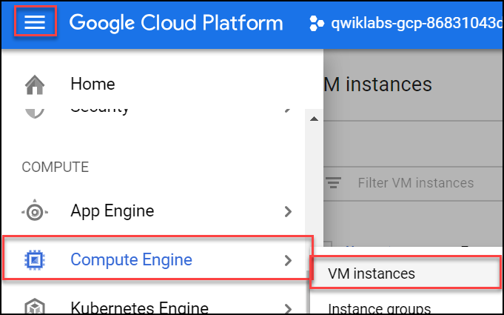

1. Fill in the fields as follows, leaving all other fields at the default value:

|  |  |
| --- | --- |
| **Field** | **Value** |
| Name | lamp-1-vm |
| Region | us-central1 (Iowa) |
| Zone | us-central1-a |
| Series | N1 |
| Machine type | n1-standard-2 |
| Firewall | check Allow HTTP traffic |

1. Click **Create**.

Wait a couple of minutes, you'll see a green check when the instance has launched.

Click **Check my progress** below. A green check confirms you're on track.

Create a Compute Engine instance (zone: us-central1-a)

Check my progress

## Add Apache2 HTTP Server to your instance

1. In the Cloud Console, click **SSH** to open a terminal to your instance.

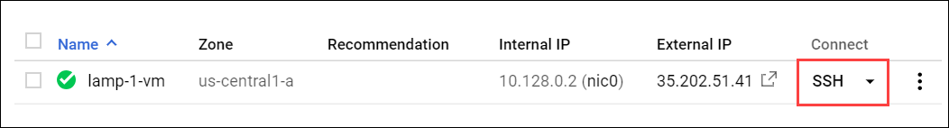

1. Run the following commands in the SSH window to set up Apache2 HTTP Server:

sudo apt-get update

content_copy

sudo apt-get install apache2 php7.0

content_copy

When asked if you want to continue, enter **Y**.

**Note:** If you cannot install php7.0, use php5.

sudo service apache2 restart

content_copy

Click **Check my progress** below. A green check confirms you're on track.

Add Apache2 HTTP Server to your instance

Check my progress

1. Return to the Cloud Console, on the VM instances page. Click the External IP for lamp-1-vm instance to see the Apache2 default page for this instance.

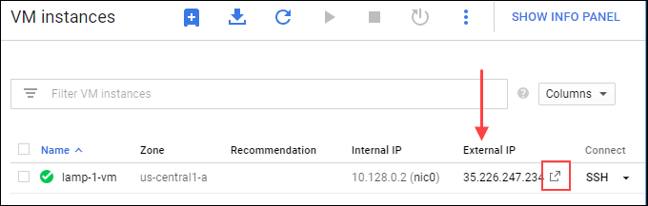

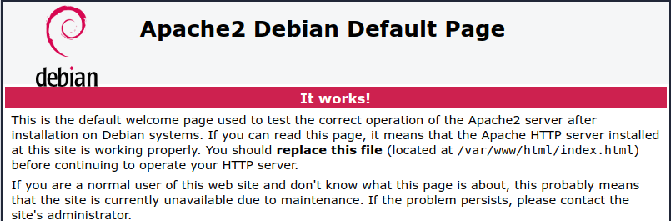

Click **Check my progress** below. A green check confirms you're on track.

Get a success response over External IP of VM instance

Check my progress

### **Create a Monitoring workspace**

Now set up a Monitoring workspace that's tied to your Google Cloud Project. The following steps create a new account that has a free trial of Monitoring.

1. In the Cloud Console, click **Navigation menu** > **Monitoring**.
2. Wait for your workspace to be provisioned.

When the Monitoring dashboard opens, your workspace is ready.

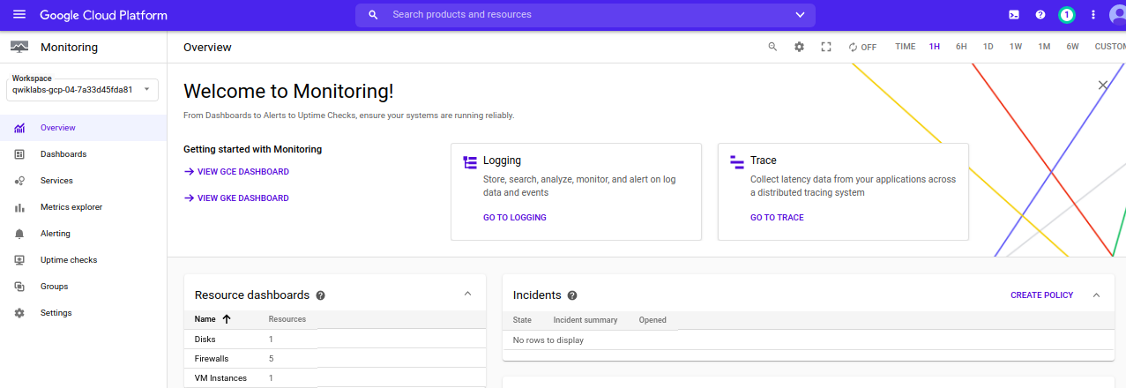

### **Install the Monitoring and Logging agents**

Agents collect data and then send or stream info to Cloud Monitoring in the Cloud Console.

The Cloud Monitoring agent is a collectd-based daemon that gathers system and application metrics from virtual machine instances and sends them to Monitoring. By default, the Monitoring agent collects disk, CPU, network, and process metrics. Configuring the Monitoring agent allows third-party applications to get the full list of agent metrics. See [Cloud Monitoring agent overview](https://cloud.google.com/monitoring/agent) for more information.

In this section, you install the Cloud Logging agent to stream logs from your VM instances to Cloud Logging. Later in this lab, you see what logs are generated when you stop and start your VM.

It is best practice to run the Cloud Logging agent on all your VM instances.

#### Install agents on the VM:

1. Run the Monitoring agent install script command in the SSH terminal of your VM instance to install the Cloud Monitoring agent.

curl -sSO https://dl.google.com/cloudagents/add-monitoring-agent-repo.sh

sudo bash add-monitoring-agent-repo.sh

content_copy

sudo apt-get update

content_copy

sudo apt-get install stackdriver-agent

content_copy

When asked if you want to continue, enter **Y**.

1. Run the Logging agent install script command in the SSH terminal of your VM instance to install the Cloud Logging agent

curl -sSO https://dl.google.com/cloudagents/add-logging-agent-repo.sh

sudo bash add-logging-agent-repo.sh

content_copy

sudo apt-get update

content_copy

sudo apt-get install google-fluentd

content_copy

## Create an uptime check

Uptime checks verify that a resource is always accessible. For practice, create an uptime check to verify your VM is up.

1. In the Cloud Console, in the left menu, click **Uptime checks**, and then click **Create Uptime Check**.

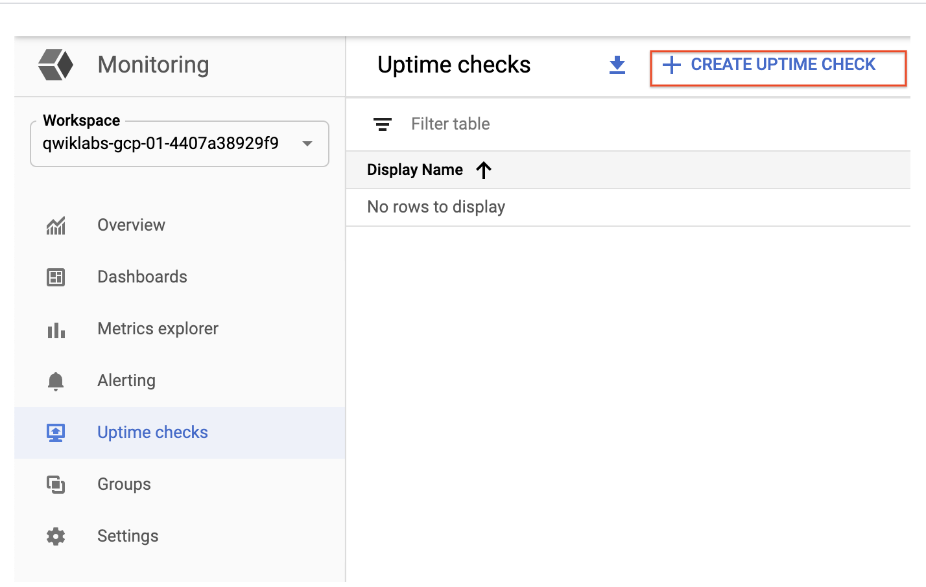

1. Set the following fields:

**Title**: Lamp Uptime Check, then click **Next**.

**Protocol**: HTTP

**Resource Type**: Instance

**Applies to**: Single, lamp-1-vm

**Path**: leave at default

**Check Frequency**: 1 min

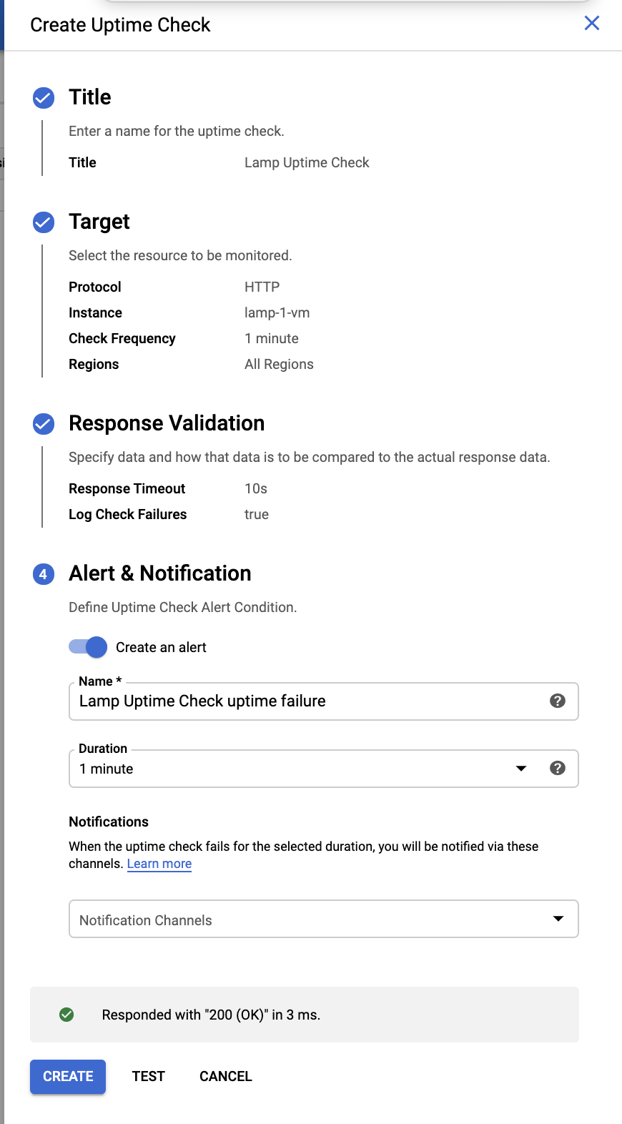

1. Click on **Next** to leave the other details to default and click **Test** to verify that your uptime check can connect to the resource.
2. When you see a green check mark everything can connect. Click **Create**.

The uptime check you configured takes a while for it to become active. Continue with the lab, you'll check for results later. While you wait, create an alerting policy for a different resource.

## Create an alerting policy

Use Cloud Monitoring to create one or more alerting policies.

1. In the left menu, click **Alerting**, and then click **Create Policy**.
2. Click **Add Condition**.

Set the following in the panel that opens, leave all other fields at the default value.

**Target**: Start typing "VM" in the resource type and metric field, and then select:

* **Resource Type**: VM Instance (gce_instance)
* **Metric**: Type "network", and then select Network traffic (gce_instance+1). Be sure to choose the Network traffic resource with agent.googleapis.com/interface/traffic:

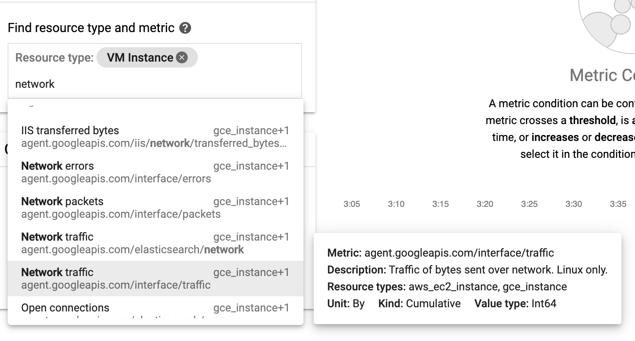

**Configuration**

* **Condition**: is above
* **Threshold**: 500
* **For**: 1 minute

Click **ADD**.

1. Click on **Next**.
2. Click on drop down arrow next to **Notification Channels**, then click on **Manage Notification Channels**.

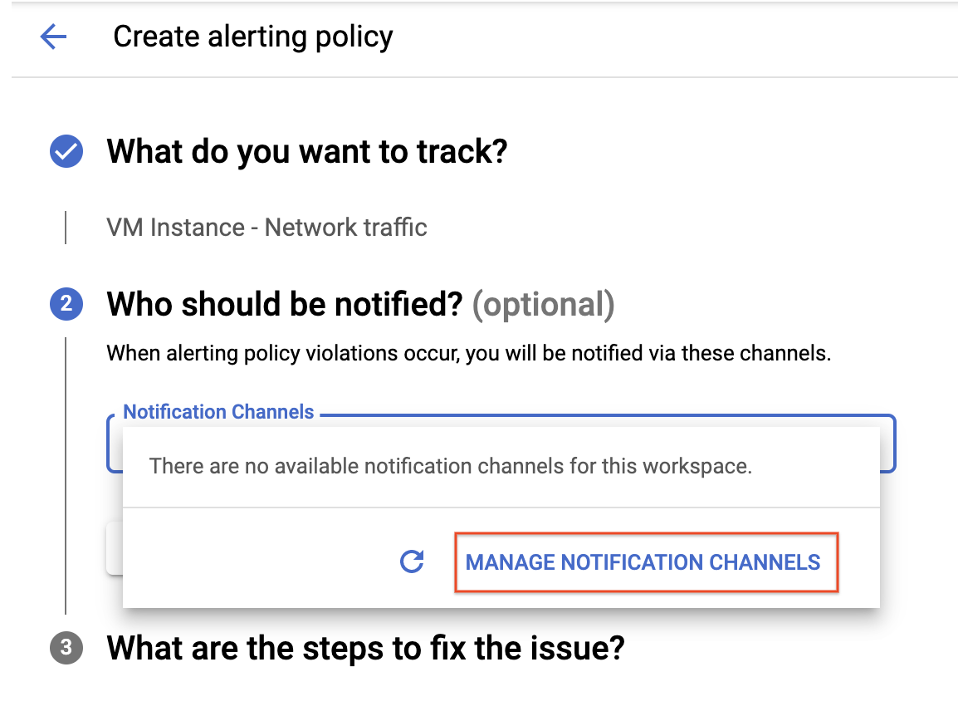

A **Notification channels** page will open in new tab.

1. Scroll down the page and click on **ADD NEW** for **Email**.



1. In **Create Email Channel** dialog box, enter your personal email address in the **Email Address** field and a **Display name**.
2. Click on **Save**.
3. Go back to the previous **Create alerting policy** tab.
4. Click on **Notification Channels** again, then click on the **Refresh icon** to get the display name you mentioned in the previous step.

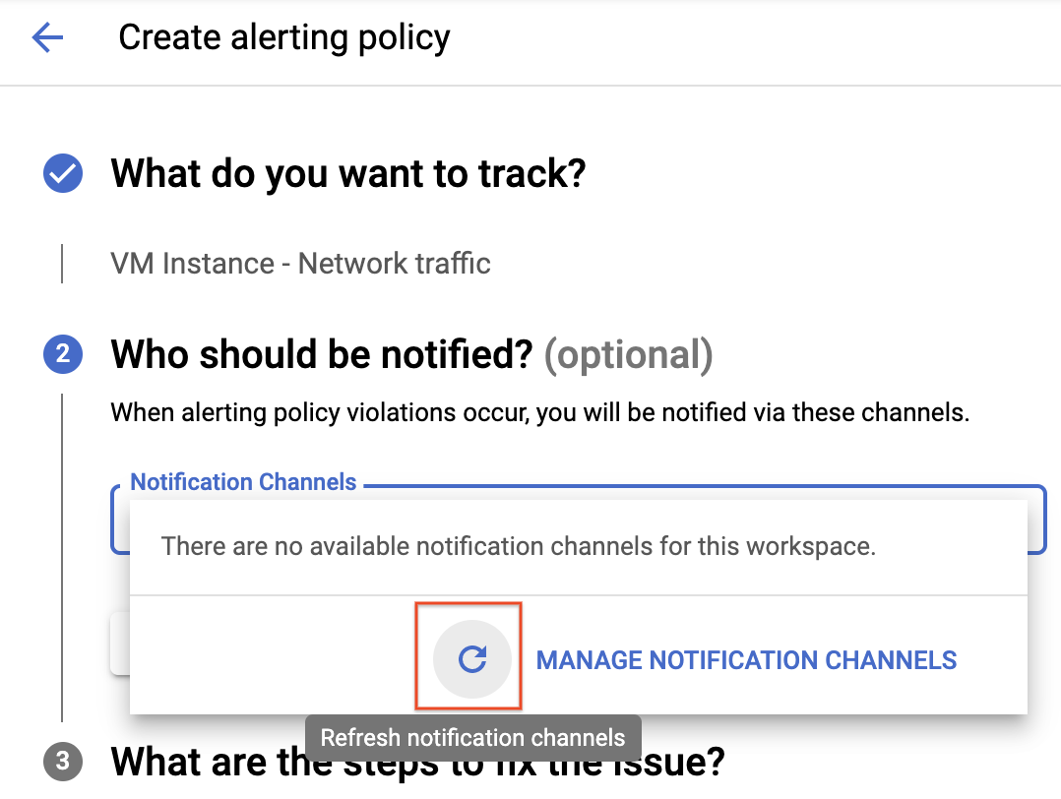

1. Now, select your **Display name** and click **OK**.
2. Click **Next**.
3. Mention the **Alert name** as Inbound Traffic Alert.
4. Add a message in documentation, which will be included in the emailed alert.
5. Click on **Save**.

You've created an alert! While you wait for the system to trigger an alert, create a dashboard and chart, and then check out Cloud Logging.

Click **Check my progress** below. A green check confirms you're on track.

Create an uptime check and alerting policy

Check my progress

## Create a dashboard and chart

You can display the metrics collected by Cloud Monitoring in your own charts and dashboards. In this section you create the charts for the lab metrics and a custom dashboard.

1. In the left menu select **Dashboards**, and then **Create Dashboard**.
2. Name the dashboard Cloud Monitoring LAMP Qwik Start Dashboard.

### **Add the first chart**

1. Click **Line** option in Chart library.
2. Name the chart title **CPU Load**.
3. Set the Resource type to **VM Instance**.
4. Set the Metric **CPU load (1m)**. Refresh the tab to view the graph.

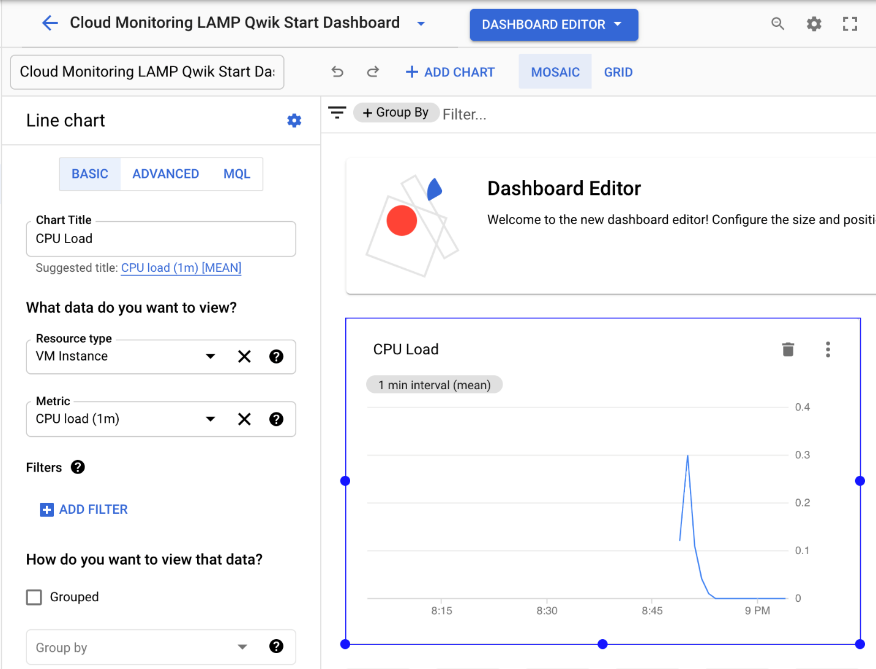

### **Add the second chart**

1. Click **+ Add Chart** and select **Line** option in Chart library.
2. Name this chart **Received Packets**.
3. Set the resource type to **VM Instance**.
4. Set the Metric **Received packets** (gce_instance). Refresh the tab to view the graph.
5. Leave the other fields at their default values. You see the chart data.

## View your logs

Cloud Monitoring and Cloud Logging are closely integrated. Check out the logs for your lab.

1. Select **Navigation menu** > **Logging** > **Logs Explorer**.
2. Select the logs you want to see, in this case, you select the logs for the lamp-1-vm instance you created at the start of this lab:

* Click on **Resource**.

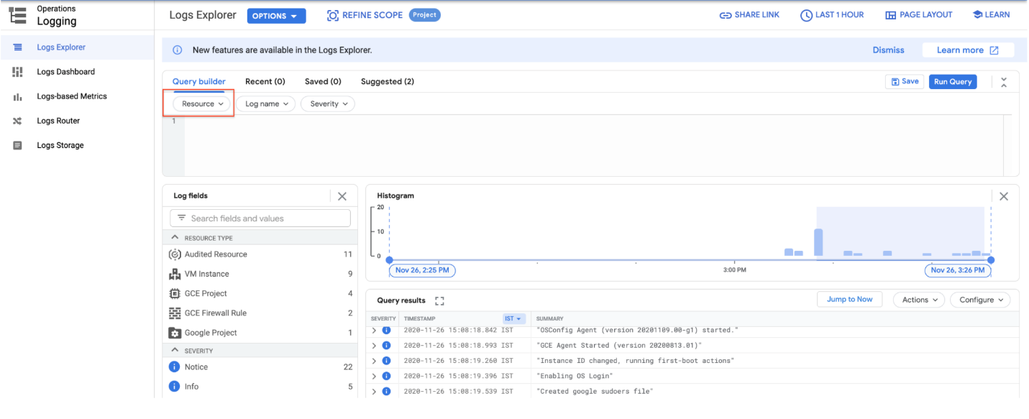

* Select **VM Instance** > **lamp-1-vm** in the Resource drop-down menu.

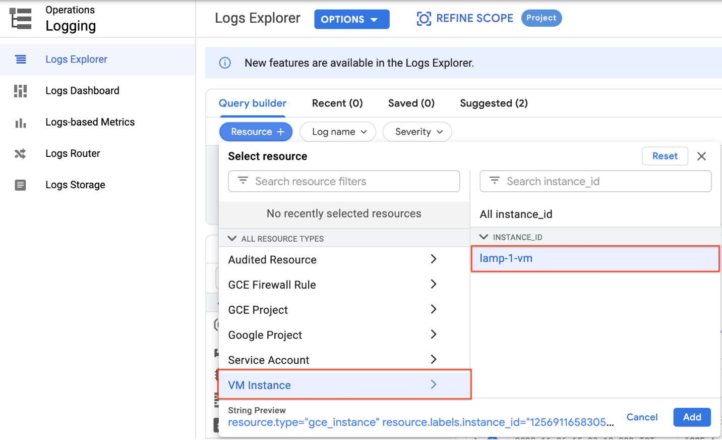

* Click **Add**.
* Leave the other fields with their default values.
* Click the **Stream logs**.

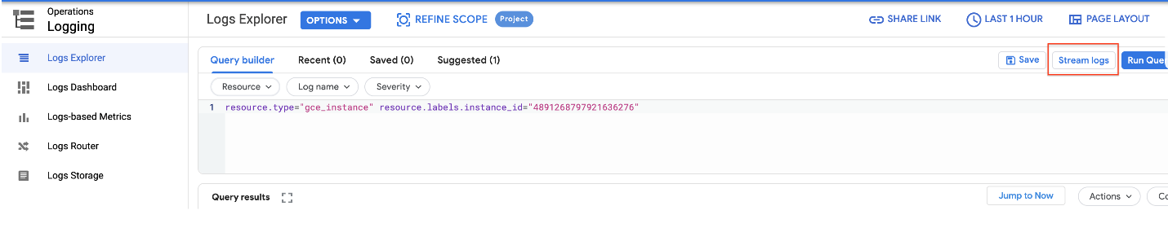

You see the logs for your VM instance:

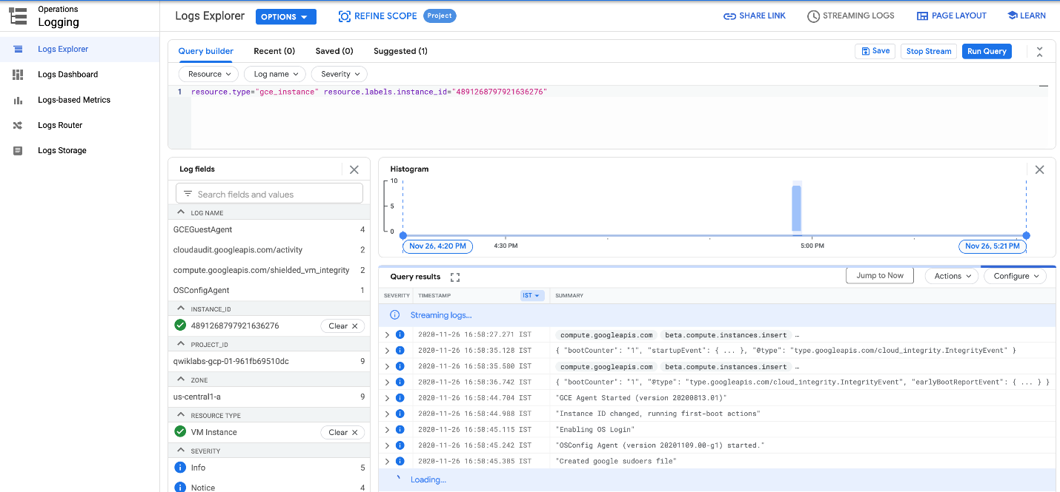

### **Check out what happens when you start and stop the VM instance.**

To best see how Cloud Monitoring and Cloud Logging reflect VM instance changes, make changes to your instance in one browser window and then see what happens in the Cloud Monitoring, and then Cloud Logging windows.

1. Open the Compute Engine window in a new browser window. Select **Navigation menu** > **Compute Engine**, right-click **VM instances** > **Open link in new window**.
2. Move the Logs Viewer browser window next to the Compute Engine window. This makes it easier to view how changes to the VM are reflected in the logs.

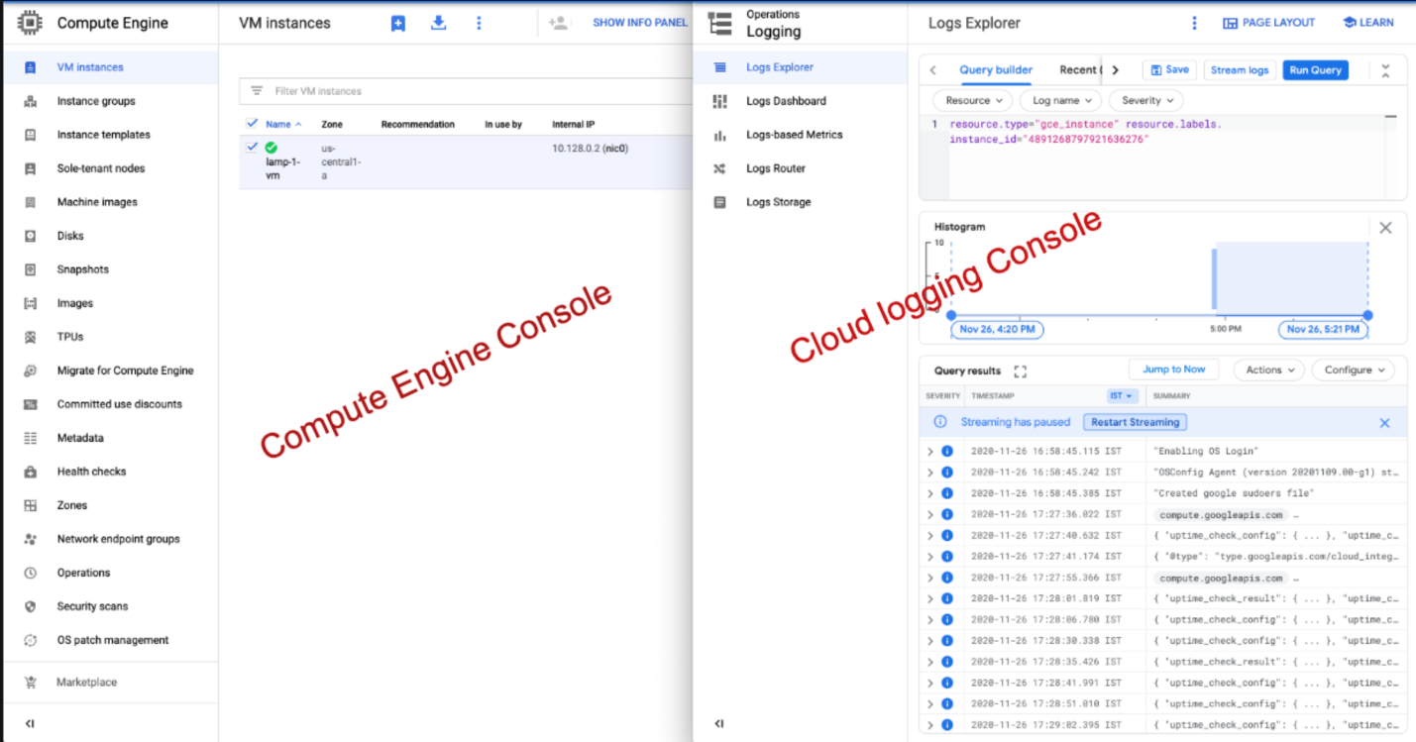

1. In the Compute Engine window, select the lamp-1-vm instance, click **Stop** at the top of the screen, and then confirm to stop the instance.

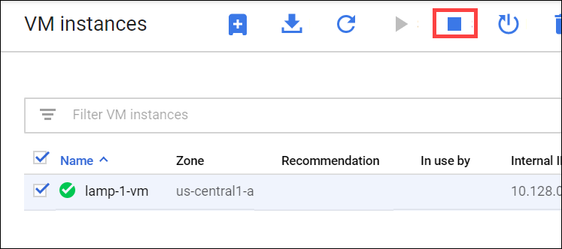

It takes a few minutes for the instance to stop.

1. Watch in the Logs View tab for when the VM is stopped.

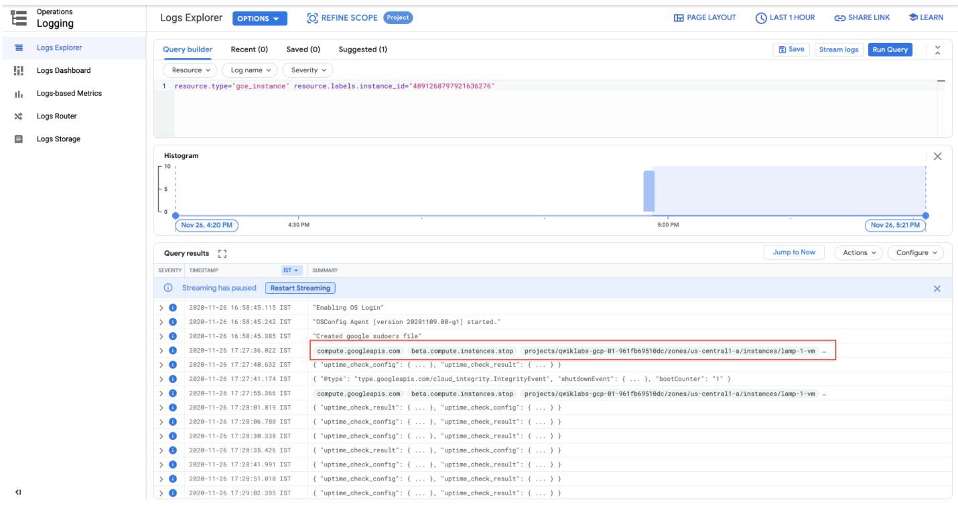

1. In the VM instance details window, click **Start** at the top of the screen, and then confirm. It will take a few minutes for the instance to re-start. Watch the log messages to monitor the start up.

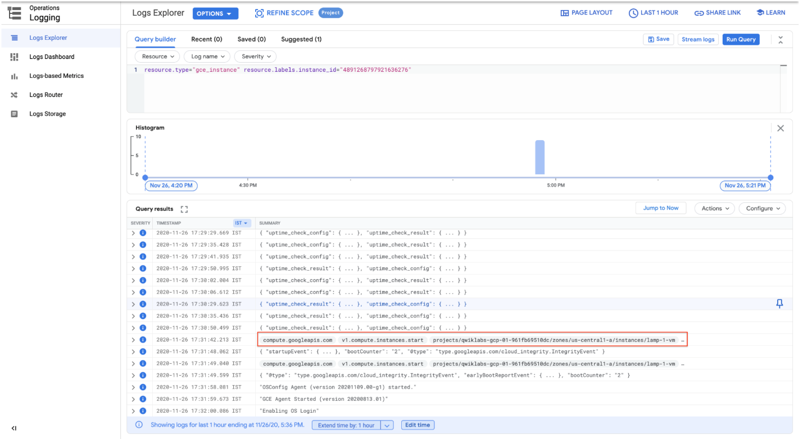

## Check the uptime check results and triggered alerts

1. In the Cloud Logging window, select **Navigation menu** > **Monitoring** > **Uptime checks**. This view provides a list of all active uptime checks, and the status of each in different locations.

You will see Lamp Uptime Check listed. Since you have just restarted your instance, the regions are in a failed status. It may take up to 5 minutes for the regions to become active. Reload your browser window as necessary until the regions are active.

1. Click the name of the uptime check, Lamp Uptime Check.

Since you have just restarted your instance, it may take some minutes for the regions to become active. Reload your browser window as necessary.

### **Check if alerts have been triggered**

1. In the left menu, click **Alerting**.
2. You see incidents and events listed in the Alerting window.
3. Check your email account. You should see Cloud Monitoring Alerts.

**Note:** Remove the email notification from your alerting policy. The resources for the lab may be active for a while after the completion, and this may result in a few more email notifications getting sent out.

Lab 5:

# Managing Deployments Using Kubernetes Engine

1 hourFree

Rate Lab

## GSP053



## Overview

Dev Ops practices will regularly make use of multiple deployments to manage application deployment scenarios such as "Continuous Deployment", "Blue-Green Deployments", "Canary Deployments" and more. This lab is to provide practice in scaling and managing containers so you can accomplish these common scenarios where multiple heterogeneous deployments are being used.

### **What you'll do**

* Practice with kubectl tool
* Create deployment yaml files
* Launch, update, and scale deployments
* Practice with updating deployments and deployment styles

### **Prerequisites**

* Before taking this lab, you should have taken at least the labs [Introduction to Docker](https://google.qwiklabs.com/catalog_lab/944) and [Hello Node Kubernetes](https://google.qwiklabs.com/catalog_lab/468)
* Linux System Administration skills
* Dev Ops theory: concepts of continuous deployment

## Introduction to deployments

Heterogeneous deployments typically involve connecting two or more distinct infrastructure environments or regions to address a specific technical or operational need. Heterogeneous deployments are called "hybrid", "multi-cloud", or "public-private", depending upon the specifics of the deployment. For the purposes of this lab, heterogeneous deployments include those that span regions within a single cloud environment, multiple public cloud environments (multi-cloud), or a combination of on-premises and public cloud environments (hybrid or public-private).

Various business and technical challenges can arise in deployments that are limited to a single environment or region:

* **Maxed out resources**: In any single environment, particularly in on-premises environments, you might not have the compute, networking, and storage resources to meet your production needs.
* **Limited geographic reach**: Deployments in a single environment require people who are geographically distant from one another to access one deployment. Their traffic might travel around the world to a central location.
* **Limited availability**: Web-scale traffic patterns challenge applications to remain fault-tolerant and resilient.
* **Vendor lock-in**: Vendor-level platform and infrastructure abstractions can prevent you from porting applications.
* **Inflexible resources**: Your resources might be limited to a particular set of compute, storage, or networking offerings.

Heterogeneous deployments can help address these challenges, but they must be architected using programmatic and deterministic processes and procedures. One-off or ad-hoc deployment procedures can cause deployments or processes to be brittle and intolerant of failures. Ad-hoc processes can lose data or drop traffic. Good deployment processes must be repeatable and use proven approaches for managing provisioning, configuration, and maintenance.

Three common scenarios for heterogeneous deployment are multi-cloud deployments, fronting on-premises data, and continuous integration/continuous delivery (CI/CD) processes.

The following exercises practice some common use cases for heterogeneous deployments, along with well-architected approaches using Kubernetes and other infrastructure resources to accomplish them.

## Setup

#### Before you click the Start Lab button

Read these instructions. Labs are timed and you cannot pause them. The timer, which starts when you click **Start Lab**, shows how long Google Cloud resources will be made available to you.

This Qwiklabs hands-on lab lets you do the lab activities yourself in a real cloud environment, not in a simulation or demo environment. It does so by giving you new, temporary credentials that you use to sign in and access Google Cloud for the duration of the lab.

#### What you need

To complete this lab, you need:

* Access to a standard internet browser (Chrome browser recommended).
* Time to complete the lab.

**Note:** If you already have your own personal Google Cloud account or project, do not use it for this lab.

**Note:** If you are using a Pixelbook, open an Incognito window to run this lab.

#### How to start your lab and sign in to the Google Cloud Console

1. Click the **Start Lab** button. If you need to pay for the lab, a pop-up opens for you to select your payment method. On the left is a panel populated with the temporary credentials that you must use for this lab.



1. Copy the username, and then click **Open Google Console**. The lab spins up resources, and then opens another tab that shows the **Sign in** page.



**Tip:** Open the tabs in separate windows, side-by-side.

If you see the **Choose an account** page, click **Use Another Account**. 

1. In the **Sign in** page, paste the username that you copied from the Connection Details panel. Then copy and paste the password.

**Important:** You must use the credentials from the Connection Details panel. Do not use your Qwiklabs credentials. If you have your own Google Cloud account, do not use it for this lab (avoids incurring charges).

1. Click through the subsequent pages:
   * Accept the terms and conditions.
   * Do not add recovery options or two-factor authentication (because this is a temporary account).
   * Do not sign up for free trials.

After a few moments, the Cloud Console opens in this tab.

**Note:** You can view the menu with a list of Google Cloud Products and Services by clicking the **Navigation menu** at the top-left. 

### **Activate Cloud Shell**

Cloud Shell is a virtual machine that is loaded with development tools. It offers a persistent 5GB home directory and runs on the Google Cloud. Cloud Shell provides command-line access to your Google Cloud resources.

In the Cloud Console, in the top right toolbar, click the **Activate Cloud Shell** button.



Click **Continue**.



It takes a few moments to provision and connect to the environment. When you are connected, you are already authenticated, and the project is set to your PROJECT_ID. For example:



gcloud is the command-line tool for Google Cloud. It comes pre-installed on Cloud Shell and supports tab-completion.

You can list the active account name with this command:

gcloud auth list

content_copy

(Output)

Credentialed accounts:

- <myaccount>@<mydomain>.com (active)content_copy

(Example output)

Credentialed accounts:

- google1623327_student@qwiklabs.netcontent_copy

You can list the project ID with this command:

gcloud config list project

content_copy

(Output)

[core]

project = <project_ID>content_copy

(Example output)

[core]

project = qwiklabs-gcp-44776a13dea667a6content_copy

For full documentation of gcloud see the [gcloud command-line tool overview](https://cloud.google.com/sdk/gcloud).

### **Set zone**

Set your working Google Cloud zone by running the following command, substituting the local zone as us-central1-a:

gcloud config set compute/zone us-central1-a

content_copy

### **Get sample code for this lab**

Get the sample code for creating and running containers and deployments:

gsutil -m cp -r gs://spls/gsp053/orchestrate-with-kubernetes .

cd orchestrate-with-kubernetes/kubernetes

content_copy

Create a cluster with five n1-standard-1 nodes (this will take a few minutes to complete):

gcloud container clusters create bootcamp --num-nodes 5 --scopes "https://www.googleapis.com/auth/projecthosting,storage-rw"

content_copy

## Learn about the deployment object

Let's get started with Deployments. First let's take a look at the Deployment object. The explain command in kubectl can tell us about the Deployment object.

kubectl explain deployment

content_copy

We can also see all of the fields using the --recursive option.

kubectl explain deployment --recursive

content_copy

You can use the explain command as you go through the lab to help you understand the structure of a Deployment object and understand what the individual fields do.

kubectl explain deployment.metadata.name

content_copy

## Create a deployment

Update the deployments/auth.yaml configuration file:

vi deployments/auth.yaml

content_copy

Start the editor:

i

content_copy

Change the image in the containers section of the Deployment to the following:

...

containers:

- name: auth

image: kelseyhightower/auth:1.0.0

...

content_copy

Save the auth.yaml file: press <Esc> then:

:wq

content_copy

Now let's create a simple deployment. Examine the deployment configuration file:

cat deployments/auth.yaml

content_copy

(Output)

apiVersion: apps/v1

kind: Deployment

metadata:

name: auth

spec:

replicas: 1

selector:

matchLabels:

app: auth

template:

metadata:

labels:

app: auth

track: stable

spec:

containers:

- name: auth

image: "kelseyhightower/auth:1.0.0"

ports:

- name: http

containerPort: 80

- name: health

containerPort: 81

...

content_copy

Notice how the Deployment is creating one replica and it's using version 1.0.0 of the auth container.

When you run the kubectl create command to create the auth deployment, it will make one pod that conforms to the data in the Deployment manifest. This means we can scale the number of Pods by changing the number specified in the replicas field.

Go ahead and create your deployment object using kubectl create:

kubectl create -f deployments/auth.yaml

content_copy

Once you have created the Deployment, you can verify that it was created.

kubectl get deployments

content_copy

Once the deployment is created, Kubernetes will create a ReplicaSet for the Deployment. We can verify that a ReplicaSet was created for our Deployment:

kubectl get replicasets

content_copy

We should see a ReplicaSet with a name like auth-xxxxxxx

Finally, we can view the Pods that were created as part of our Deployment. The single Pod is created by the Kubernetes when the ReplicaSet is created.

kubectl get pods

content_copy

It's time to create a service for our auth deployment. You've already seen service manifest files, so we won't go into the details here. Use the kubectl create command to create the auth service.

kubectl create -f services/auth.yaml

content_copy

Now, do the same thing to create and expose the hello Deployment.

kubectl create -f deployments/hello.yaml

kubectl create -f services/hello.yaml

content_copy

And one more time to create and expose the frontend Deployment.

kubectl create secret generic tls-certs --from-file tls/

kubectl create configmap nginx-frontend-conf --from-file=nginx/frontend.conf

kubectl create -f deployments/frontend.yaml

kubectl create -f services/frontend.yaml

content_copy

**Note:** You created a ConfigMap for the frontend.

Interact with the frontend by grabbing its external IP and then curling to it.

kubectl get services frontend

content_copy

It may take a few seconds before the External-IP field is populated for your service. This is normal. Just re-run the above command every few seconds until the field is populated.

curl -ks https://<EXTERNAL-IP>

content_copy

And you get the hello response back.

You can also use the output templating feature of kubectl to use curl as a one-liner:

curl -ks https://`kubectl get svc frontend -o=jsonpath="{.status.loadBalancer.ingress[0].ip}"`

content_copy

#### Test Completed Task

Click **Check my progress** below to check your lab progress. If you successfully created Kubernetes cluster and Auth, Hello and Frontend deployments, you'll see an assessment score.

Create a Kubernetes cluster and deployments (Auth, Hello, and Frontend)

Check my progress

### **Scale a Deployment**

Now that we have a Deployment created, we can scale it. Do this by updating the spec.replicas field. You can look at an explanation of this field using the kubectl explain command again.

kubectl explain deployment.spec.replicas

content_copy

The replicas field can be most easily updated using the kubectl scale command:

kubectl scale deployment hello --replicas=5

content_copy

**Note:** It may take a minute or so for all the new pods to start up.

After the Deployment is updated, Kubernetes will automatically update the associated ReplicaSet and start new Pods to make the total number of Pods equal 5.

Verify that there are now 5 hello Pods running:

kubectl get pods | grep hello- | wc -l

content_copy

Now scale back the application:

kubectl scale deployment hello --replicas=3

content_copy

Again, verify that you have the correct number of Pods.

kubectl get pods | grep hello- | wc -l

content_copy

You learned about Kubernetes deployments and how to manage & scale a group of Pods.

## Rolling update

Deployments support updating images to a new version through a rolling update mechanism. When a Deployment is updated with a new version, it creates a new ReplicaSet and slowly increases the number of replicas in the new ReplicaSet as it decreases the replicas in the old ReplicaSet.

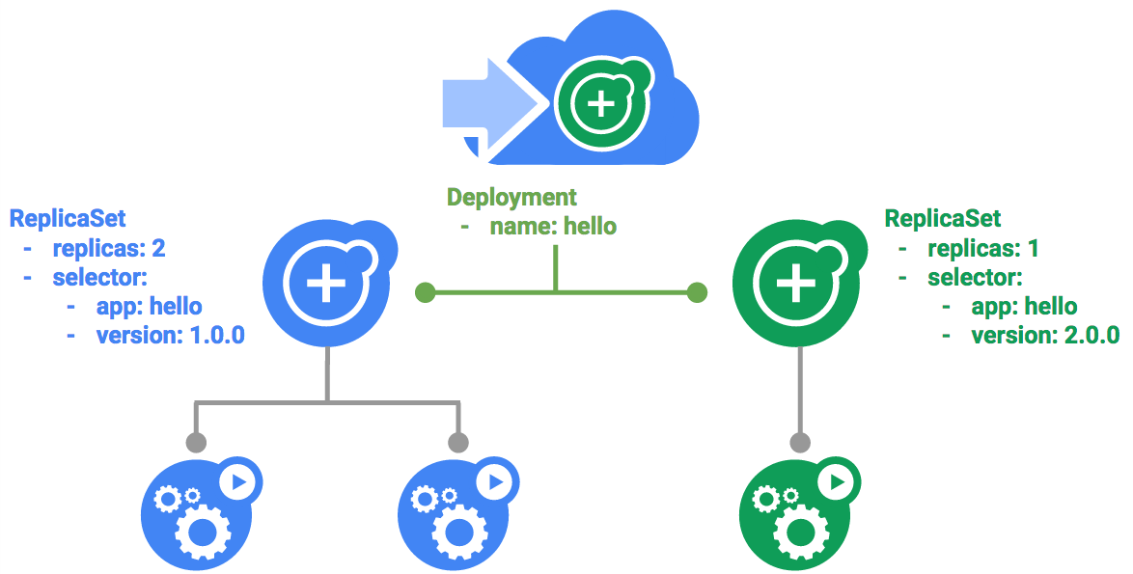

### **Trigger a rolling update**

To update your Deployment, run the following command:

kubectl edit deployment hello

content_copy

Change the image in the containers section of the Deployment to the following:

...

containers:

image: kelseyhightower/hello:2.0.0

...

content_copy

Save and exit.

Once you save out of the editor, the updated Deployment will be saved to your cluster and Kubernetes will begin a rolling update.

See the new ReplicaSet that Kubernetes creates.:

kubectl get replicaset

content_copy

You can also see a new entry in the rollout history:

kubectl rollout history deployment/hello

content_copy

### **Pause a rolling update**

If you detect problems with a running rollout, pause it to stop the update. Give that a try now:

kubectl rollout pause deployment/hello

content_copy

Verify the current state of the rollout:

kubectl rollout status deployment/hello

content_copy

You can also verify this on the Pods directly:

kubectl get pods -o jsonpath --template='{range .items[*]}{.metadata.name}{"\t"}{"\t"}{.spec.containers[0].image}{"\n"}{end}'

content_copy

### **Resume a rolling update**

The rollout is paused which means that some pods are at the new version and some pods are at the older version. We can continue the rollout using the resume command.

kubectl rollout resume deployment/hello

content_copy

When the rollout is complete, you should see the following when running the status command.

kubectl rollout status deployment/hello

content_copy

(Output)

deployment "hello" successfully rolled out

content_copy

### **Rollback an update**

Assume that a bug was detected in your new version. Since the new version is presumed to have problems, any users connected to the new Pods will experience those issues.

You will want to roll back to the previous version so you can investigate and then release a version that is fixed properly.

Use the rollout command to roll back to the previous version:

kubectl rollout undo deployment/hello

content_copy

Verify the roll back in the history:

kubectl rollout history deployment/hello

content_copy

Finally, verify that all the Pods have rolled back to their previous versions:

kubectl get pods -o jsonpath --template='{range .items[*]}{.metadata.name}{"\t"}{"\t"}{.spec.containers[0].image}{"\n"}{end}'

content_copy

Great! You learned about rolling updates for Kubernetes deployments and how to update applications without downtime.

## Canary deployments

When you want to test a new deployment in production with a subset of your users, use a canary deployment. Canary deployments allow you to release a change to a small subset of your users to mitigate risk associated with new releases.

### **Create a canary deployment**

A canary deployment consists of a separate deployment with your new version and a service that targets both your normal, stable deployment as well as your canary deployment.

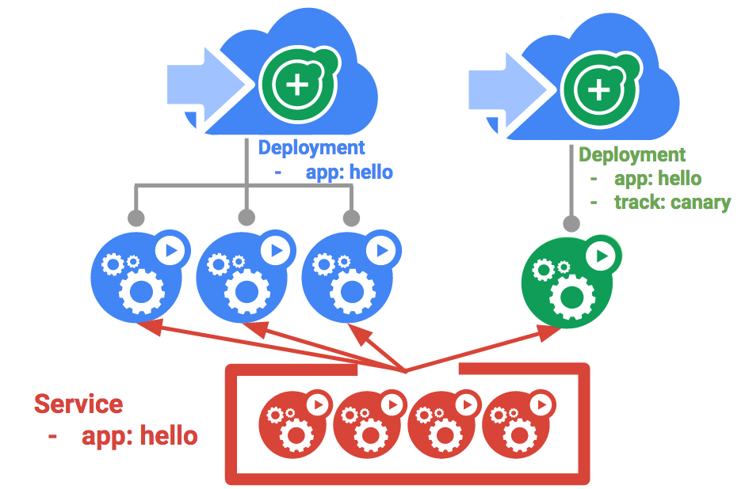

First, create a new canary deployment for the new version:

cat deployments/hello-canary.yaml

content_copy

(Output)

apiVersion: apps/v1

kind: Deployment

metadata:

name: hello-canary

spec:

replicas: 1

selector:

matchLabels:

app: hello

template:

metadata:

labels:

app: hello

track: canary

# Use ver 1.0.0 so it matches version on service selector

version: 2.0.0

spec:

containers:

- name: hello

image: kelseyhightower/hello:2.0.0

ports:

- name: http

containerPort: 80

- name: health

containerPort: 81

...

content_copy

Now create the canary deployment:

kubectl create -f deployments/hello-canary.yaml

content_copy

After the canary deployment is created, you should have two deployments, hello and hello-canary. Verify it with this kubectl command:

kubectl get deployments

content_copy

On the hello service, the selector uses the app:hello selector which will match pods in **both** the prod deployment and canary deployment. However, because the canary deployment has a fewer number of pods, it will be visible to fewer users.

### **Verify the canary deployment**

You can verify the hello version being served by the request:

curl -ks https://`kubectl get svc frontend -o=jsonpath="{.status.loadBalancer.ingress[0].ip}"`/version

content_copy

Run this several times and you should see that some of the requests are served by hello 1.0.0 and a small subset (1/4 = 25%) are served by 2.0.0.

#### Test Completed Task

Click **Check my progress** below to check your lab progress. If you successfully created Canary deployment, you'll see an assessment score.

Canary Deployment

Check my progress

### **Canary deployments in production - session affinity**

In this lab, each request sent to the Nginx service had a chance to be served by the canary deployment. But what if you wanted to ensure that a user didn't get served by the Canary deployment? A use case could be that the UI for an application changed, and you don't want to confuse the user. In a case like this, you want the user to "stick" to one deployment or the other.

You can do this by creating a service with session affinity. This way the same user will always be served from the same version. In the example below the service is the same as before, but a new sessionAffinity field has been added, and set to ClientIP. All clients with the same IP address will have their requests sent to the same version of the hello application.

kind: Service

apiVersion: v1

metadata:

name: "hello"

spec:

sessionAffinity: ClientIP

selector:

app: "hello"

ports:

- protocol: "TCP"

port: 80

targetPort: 80

content_copy

Due to it being difficult to set up an environment to test this, you don't need to here, but you may want to use sessionAffinity for canary deployments in production.

## Blue-green deployments

Rolling updates are ideal because they allow you to deploy an application slowly with minimal overhead, minimal performance impact, and minimal downtime. There are instances where it is beneficial to modify the load balancers to point to that new version only after it has been fully deployed. In this case, blue-green deployments are the way to go.

Kubernetes achieves this by creating two separate deployments; one for the old "blue" version and one for the new "green" version. Use your existing hello deployment for the "blue" version. The deployments will be accessed via a Service which will act as the router. Once the new "green" version is up and running, you'll switch over to using that version by updating the Service.

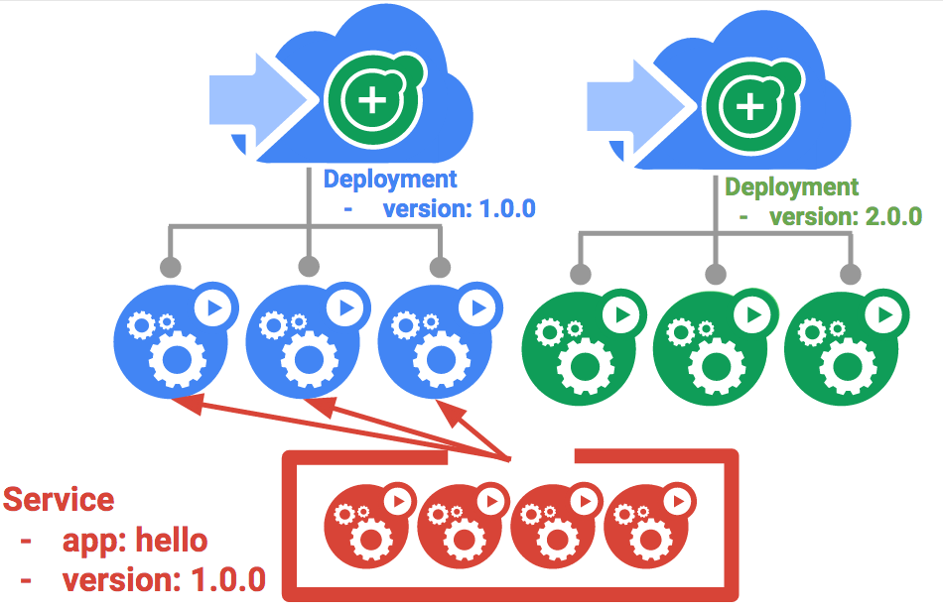

A major downside of blue-green deployments is that you will need to have at least 2x the resources in your cluster necessary to host your application. Make sure you have enough resources in your cluster before deploying both versions of the application at once.

### **The service**

Use the existing hello service, but update it so that it has a selector app:hello, version: 1.0.0. The selector will match the existing "blue" deployment. But it will not match the "green" deployment because it will use a different version.

First update the service:

kubectl apply -f services/hello-blue.yaml

content_copy

**NOTE:** Ignore the warning that says resource service/hello is missing as this is patched automatically.

### **Updating using Blue-Green Deployment**

In order to support a blue-green deployment style, we will create a new "green" deployment for our new version. The green deployment updates the version label and the image path.

apiVersion: apps/v1

kind: Deployment

metadata:

name: hello-green

spec:

replicas: 3

selector:

matchLabels:

app: hello

template:

metadata:

labels:

app: hello

track: stable

version: 2.0.0

spec:

containers:

- name: hello

image: kelseyhightower/hello:2.0.0

ports:

- name: http

containerPort: 80

- name: health

containerPort: 81

resources:

limits:

cpu: 0.2

memory: 10Mi

livenessProbe:

httpGet:

path: /healthz

port: 81

scheme: HTTP

initialDelaySeconds: 5

periodSeconds: 15

timeoutSeconds: 5

readinessProbe:

httpGet:

path: /readiness

port: 81

scheme: HTTP

initialDelaySeconds: 5

timeoutSeconds: 1

content_copy

Create the green deployment:

kubectl create -f deployments/hello-green.yaml

content_copy

Once you have a green deployment and it has started up properly, verify that the current version of 1.0.0 is still being used:

curl -ks https://`kubectl get svc frontend -o=jsonpath="{.status.loadBalancer.ingress[0].ip}"`/version

content_copy

Now, update the service to point to the new version:

kubectl apply -f services/hello-green.yaml

content_copy

With the service is updated, the "green" deployment will be used immediately. You can now verify that the new version is always being used.

curl -ks https://`kubectl get svc frontend -o=jsonpath="{.status.loadBalancer.ingress[0].ip}"`/version

content_copy

### **Blue-Green Rollback**

If necessary, you can roll back to the old version in the same way. While the "blue" deployment is still running, just update the service back to the old version.

kubectl apply -f services/hello-blue.yaml

content_copy

Once you have updated the service, your rollback will have been successful. Again, verify that the right version is now being used:

curl -ks https://`kubectl get svc frontend -o=jsonpath="{.status.loadBalancer.ingress[0].ip}"`/version

content_copy

You did it! You learned about blue-green deployments and how to deploy updates to applications that need to switch versions all at once.

# Deployment Manager - Full Production

1 hour 30 minutesFree

## GSP060



## Overview

In this lab, you launch a service using an infrastructure orchestration tool called Deployment Manager and monitor the service using Cloud Monitoring. In Cloud Monitoring, you set up basic black box monitoring with a Cloud Monitoring dashboard and establish an Uptime Check (alert notification) to trigger incident response.

More specifically, you:

1. Install and configure an advanced deployment using Deployment Manager sample templates.
2. Enable Cloud Monitoring.
3. Configure Cloud Monitoring Uptime Checks and notifications.
4. Configure a Cloud Monitoring dashboard with two charts, one showing CPU usage and the other ingress traffic.
5. Perform a load test and simulate a service outage.

Cloud Monitoring provides visibility into the performance, uptime, and overall health of cloud-powered applications.It collects metrics, events, and metadata from Google Cloud, Amazon Web Services, hosted uptime probes, application instrumentation, and a variety of common application components including Cassandra, Nginx, Apache Web Server, Elasticsearch, and many others. Cloud Monitoring ingests that data and generates insights via dashboards, charts, and alerts. Cloud Monitoring alerting helps you collaborate by integrating with Slack, PagerDuty, HipChat, Campfire, and more.

## Objectives

In this lab, you learn to:

* Launch a cloud service from a collection of templates.
* Configure basic black box monitoring of an application.
* Create an uptime check to recognize a loss of service.
* Establish an alerting policy to trigger incident response procedures.
* Create and configure a dashboard with dynamically updated charts.
* Test the monitoring and alerting regimen by applying a load to the service.
* Test the monitoring and alerting regimen by simulating a service outage.

## Setup and Requirements

#### Before you click the Start Lab button

Read these instructions. Labs are timed and you cannot pause them. The timer, which starts when you click **Start Lab**, shows how long Google Cloud resources will be made available to you.

This Qwiklabs hands-on lab lets you do the lab activities yourself in a real cloud environment, not in a simulation or demo environment. It does so by giving you new, temporary credentials that you use to sign in and access Google Cloud for the duration of the lab.

#### What you need

To complete this lab, you need:

* Access to a standard internet browser (Chrome browser recommended).
* Time to complete the lab.

**Note:** If you already have your own personal Google Cloud account or project, do not use it for this lab.

**Note:** If you are using a Pixelbook, open an Incognito window to run this lab.

#### How to start your lab and sign in to the Google Cloud Console

1. Click the **Start Lab** button. If you need to pay for the lab, a pop-up opens for you to select your payment method. On the left is a panel populated with the temporary credentials that you must use for this lab.



1. Copy the username, and then click **Open Google Console**. The lab spins up resources, and then opens another tab that shows the **Sign in** page.



**Tip:** Open the tabs in separate windows, side-by-side.

If you see the **Choose an account** page, click **Use Another Account**. 

1. In the **Sign in** page, paste the username that you copied from the Connection Details panel. Then copy and paste the password.

**Important:** You must use the credentials from the Connection Details panel. Do not use your Qwiklabs credentials. If you have your own Google Cloud account, do not use it for this lab (avoids incurring charges).

1. Click through the subsequent pages:
   * Accept the terms and conditions.
   * Do not add recovery options or two-factor authentication (because this is a temporary account).
   * Do not sign up for free trials.

After a few moments, the Cloud Console opens in this tab.

**Note:** You can view the menu with a list of Google Cloud Products and Services by clicking the **Navigation menu** at the top-left. 

### **Activate Cloud Shell**

Cloud Shell is a virtual machine that is loaded with development tools. It offers a persistent 5GB home directory and runs on the Google Cloud. Cloud Shell provides command-line access to your Google Cloud resources.

In the Cloud Console, in the top right toolbar, click the **Activate Cloud Shell** button.



Click **Continue**.



It takes a few moments to provision and connect to the environment. When you are connected, you are already authenticated, and the project is set to your PROJECT_ID. For example:



gcloud is the command-line tool for Google Cloud. It comes pre-installed on Cloud Shell and supports tab-completion.

You can list the active account name with this command:

gcloud auth list

content_copy

(Output)

Credentialed accounts:

- <myaccount>@<mydomain>.com (active)content_copy

(Example output)

Credentialed accounts:

- google1623327_student@qwiklabs.netcontent_copy

You can list the project ID with this command:

gcloud config list project

content_copy

(Output)

[core]

project = <project_ID>content_copy

(Example output)

[core]

project = qwiklabs-gcp-44776a13dea667a6content_copy

For full documentation of gcloud see the [gcloud command-line tool overview](https://cloud.google.com/sdk/gcloud).

## Create a virtual environment

Execute the following command to download and update the packages list.

sudo apt-get update

content_copy

Python virtual environments are used to isolate package installation from the system.

sudo apt-get install virtualenv

content_copy

If prompted [Y/n], press Y and then Enter.

virtualenv -p python3 venv

content_copy

Activate the virtual environment.

source venv/bin/activate

content_copy

## Clone the Deployment Manager Sample Templates

Google provides a robust set of sample Deployment Manager templates that you can learn from and build upon.

To clone the repository, enter the following commands in Cloud Shell Command Line to create a directory to hold the Deployment Manager sample templates.

mkdir ~/dmsamples

content_copy

Go to that directory.

cd ~/dmsamples

content_copy

Clone the repository to the directory you just made.

git clone https://github.com/GoogleCloudPlatform/deploymentmanager-samples.git

content_copy

**Example Output:**

remote: Counting objects: 1917, done.

remote: Compressing objects: 100% (31/31), done.

remote: Total 1917 (delta 11), reused 29 (delta 7), pack-reused 1874

Receiving objects: 100% (1917/1917), 426.86 KiB | 0 bytes/s, done.

Resolving deltas: 100% (1060/1060), done.content_copy

## Explore the Sample Files

We just downloaded a collection of sample templates to our directory, let's dive in and explore some of them.

### **List the example templates**

Run the following commands to navigate to and list the version2 examples:

cd ~/dmsamples/deploymentmanager-samples/examples/v2

content_copy

ls

content_copy

You should see something like this:

access_context_manager cloud_functions common folder_creation iam_custom_role internal_lb_haproxy quick_start ssl vm_with_disks

access_control cloudkms container_igm gke igm-updater metadata_from_file regional_igm step_by_step_guide vpn_auto_subnet

bigtable cloud_router container_vm ha-service image_based_igm nodejs saltstack template_modules waiter

build_configuration cloudsql custom_machine_type htcondor instance_pool nodejs_l7 single_vm vlan_attachment

cloudbuild cloudsql_import dataproc iam internal_lb project_creation sqladmin vm_startup_scriptcontent_copy

Not all of the subdirectories are independent projects. For example, the directory named **common** contains templates that are used by several of the other projects. If you are studying independently later, use the README files as a guide.

The nodejs directory contains everything you need to build this lab. Note that there is a nodejs directory and a nodejs_l7directory. Use nodejs.

### **List and examine the Nodejs deployment**

Navigate to and list the version2 examples:

cd nodejs/python

content_copy

ls

content_copy

**Example Output:**

frontend.py frontend.py.schema nodejs.py nodejs.py.schema nodejs.yamlcontent_copy

The main deployment manager configuration file is nodejs.yaml. It makes use of templates to generate infrastructure. The rest of the files are templates. Templates use variables defined in the nodejs.yaml configuration file to produce customized results.

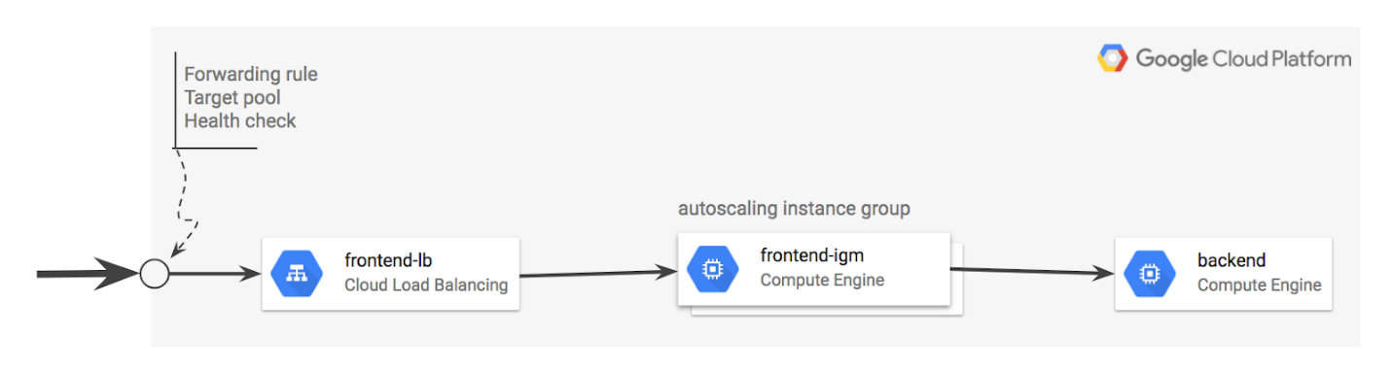

### **frontend.py**

frontend.py includes frontend.py.schema, which creates an instance template based on container_instance_template.py. This template is used to create a managed instance group and an autoscaler. The template also creates a network load balancer that has a forwarding rule with a single public IP address. It also creates:

* A target pool that refers to the managed instance group.
* A health check attached to the target pool.

### **nodejs.py**

nodejs.py includes nodejs.py.schema, which brings the frontend and backend templates together.

* Note that the frontend is frontend.py.
* The backend is /common/python/container_vm.py.
* This is a VM running a Docker container with MySQL, so it doesn't require a custom template.

### **Other files**

* /common/python/container_instance_template.py
* /common/python/container_vm.py
* /common/python/container_helper.py

## Customize the Deployment

Now that you've downloaded and reviewed the nodejs Deployment Manager template, let's start customizing the deployment.

### **Specify the zone**

The nodejs.yaml file requires a zone, and you'll now add one to the file.

1. Enter the following command to open the list of zones:

gcloud compute zones list

content_copy

Copy the name of a zone for the configuration file to use.

1. Open nodejs.yaml in nano so you can edit the zone value:

nano nodejs.yaml

content_copy

The nodejs.yaml file contents:

resources:

- name: nodejs

type: nodejs.py

properties:

zone: ZONE_TO_RUNcontent_copy

1. Replace ZONE_TO_RUN with a zone name that's near you, then exit nano and save the file.

This example shows ZONE_TO_RUN set to us-east1-d

resources:

- name: nodejs

type: nodejs.py

properties:

zone: us-east1-dcontent_copy

### **Modify the maximum number of instances in the instance group**

Edit the nodejs.py file.

1. Enter this command to open nodejs.py in nano:

nano nodejs.py

content_copy

1. Verify current scaling limit for frontend in nodejs.py

{

'name': frontend,

'type': 'frontend.py',

'properties': {

'zone': context.properties['zone'],

'dockerImage': 'gcr.io/deployment-manager-examples/nodejsservice',

'port': application_port,

# Define the variables that are exposed to container as env variables.

'dockerEnv': {

'SEVEN_SERVICE_MYSQL_PORT': mysql_port,

'SEVEN_SERVICE_PROXY_HOST': '$(ref.' + backend

+ '.networkInterfaces[0].networkIP)'

},

# If left out will default to 1

'size': 2,

# If left out will default to 1

'maxSize': 20

}

},

content_copy

Current scaling limit is 20 (refer maxSize).

1. Modify the maxSize and set it to 4:

{

'name': frontend,

'type': 'frontend.py',

'properties': {

'zone': context.properties['zone'],

'dockerImage': 'gcr.io/deployment-manager-examples/nodejsservice',

'port': application_port,

# Define the variables that are exposed to container as env variables.

'dockerEnv': {

'SEVEN_SERVICE_MYSQL_PORT': mysql_port,

'SEVEN_SERVICE_PROXY_HOST': '$(ref.' + backend

+ '.networkInterfaces[0].networkIP)'

},

# If left out will default to 1

'size': 2,

# If left out will default to 1

'maxSize': 4

}

},

content_copy

Save the file and exit nano when you're done.

## Run the Application

Now you'll use Deployment Manager to deploy the application and make it operational. This builds the infrastructure, but it won't allow traffic. After Deployment Manager sets up the infrastructure, you can apply service labels.

### **Deploy the application**

Enter this command to name the application advanced-configuration and pass Deployment Manager the configuration file (nodejs.yaml).

gcloud deployment-manager deployments create advanced-configuration --config nodejs.yaml

content_copy

Output:

The fingerprint of the deployment is PiYc6OsIFkWzQpCDklHvaA==

Waiting for create [operation-1529913842103-56f72d31872d9-90070017-aec5761d]...done.

Create operation operation-1529913842103-56f72d31872d9-90070017-aec5761d completed successfully.

NAME TYPE STATE ERRORS INTENT

advanced-configuration-application-fw compute.v1.firewall COMPLETED []

advanced-configuration-backend compute.v1.instance COMPLETED []

advanced-configuration-frontend-as compute.v1.autoscaler COMPLETED []

advanced-configuration-frontend-hc compute.v1.httpHealthCheck COMPLETED []

advanced-configuration-frontend-igm compute.v1.instanceGroupManager COMPLETED []

advanced-configuration-frontend-it compute.v1.instanceTemplate COMPLETED []

advanced-configuration-frontend-lb compute.v1.forwardingRule COMPLETED []

advanced-configuration-frontend-tp compute.v1.targetPool COMPLETED []content_copy

Click **Check my progress** below to check your lab progress.

Deploy the application

Check my progress

Confirm the limit for the maximum number of instances:

1. Go to **Compute Engine** > **Instance groups**.

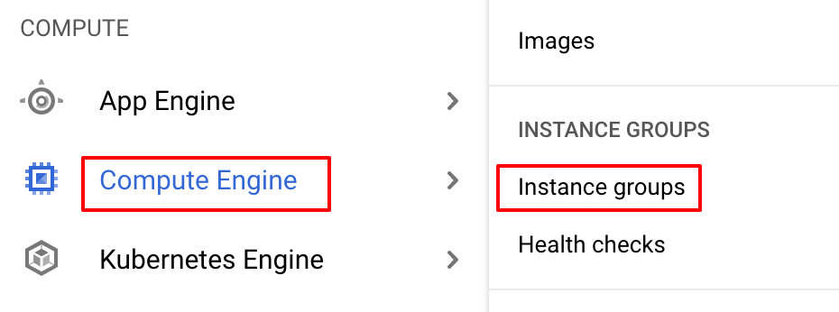

1. Click on **advanced-configuration-frontend-igm**. 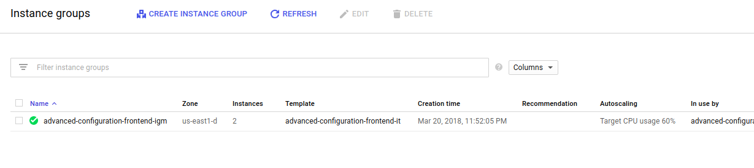
2. Click on the **Details** tab, then verify the maximum number of instances. 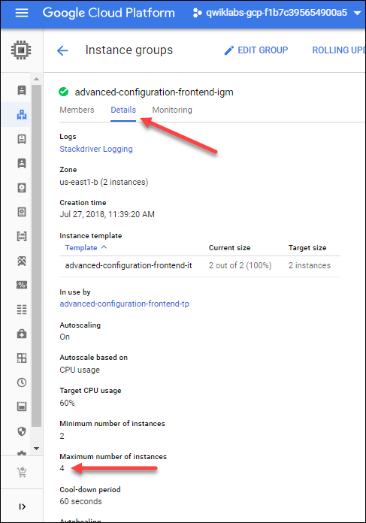

You'll see it has been set to 4.

## Verify that the application is operational

The application takes a few minutes to start. You can view it in the Deployment Manager part of Cloud Console (**Navigation menu** > **Deployment Manager**), or you can see the instances in the Compute Engine part of Console (**Navigation menu** > **Compute Engine** > **VM Instances**).

To verify that the application is running, open a browser to access port 8080 and view the service. Since the IP address was established dynamically when the Deployment Manager implemented the global forwarding rule (specified in the template), you'll need to find that address to test the application.

### **Find the global load balancer forwarding rule IP address**

1. Enter the following command in the Cloud Command Line to find your forwarding IP address.

gcloud compute forwarding-rules list

content_copy

**Example output:**

 Your forwarding IP address is the IP_ADDRESS listed in your output. Be sure to record it; you'll use it a few times in this lab.

1. Open a new window in your browser. In the address field, enter the following URL, replacing <your IP address> with your forwarding IP address:

http://<your IP address>:8080

content_copy

You see a blank page, similar to below, with your own IP address:

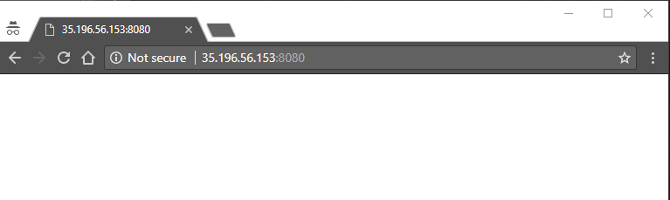

It may take up to 10 minutes for the service to become operational. If you get an error, such as a 404, or a time out, wait about two minutes and try again.

1. Now enter log information by entering a log message in your browser address line.

http://<your forwarding IP address>:8080/?msg=<enter_a_message>

content_copy

Replace enter_a_message with any kind of message.

These are log message examples - you have a different IP address:

http://35.196.56.153:8080/?msg=my dog has spotscontent_copy

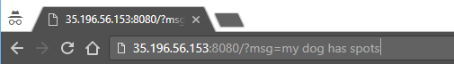

After you enter the log, the browser returns added.

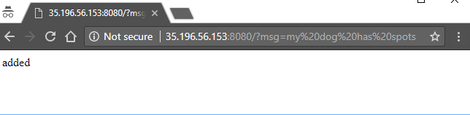

1. View the log by going to http://<your IP address>:8080. For example:

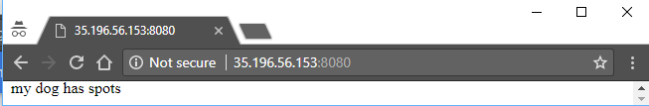

Go ahead and create more logs and see them at http://<your IP address>:8080.

## Configure an uptime check and alert policy in Cloud Monitoring

### **Create a Monitoring workspace**

Now set up a Monitoring workspace that's tied to your Google Cloud Project. The following steps create a new account that has a free trial of Monitoring.

1. In the Cloud Console, click **Navigation menu** > **Monitoring**.
2. Wait for your workspace to be provisioned.

When the Monitoring dashboard opens, your workspace is ready.



### **Configure an uptime check**

The Cloud Monitoring window opens.

1. In the Cloud Monitoring tab, click on **Uptime Checks**
2. Click **Create Uptime Check**.
3. In the **Create Uptime Check** page set the following fields:

**Title**: Check1, then click **Next**

**Protocol**: TCP

**Resource Type**: URL

**Hostname**: <your forwarding address> (you previously recorded)

**Port**: 8080

**Check Frequency**: 1 minute, then click **Next**

**Response Content**: <leave blank>, click **Next**

1. Click **TEST** to test the check:

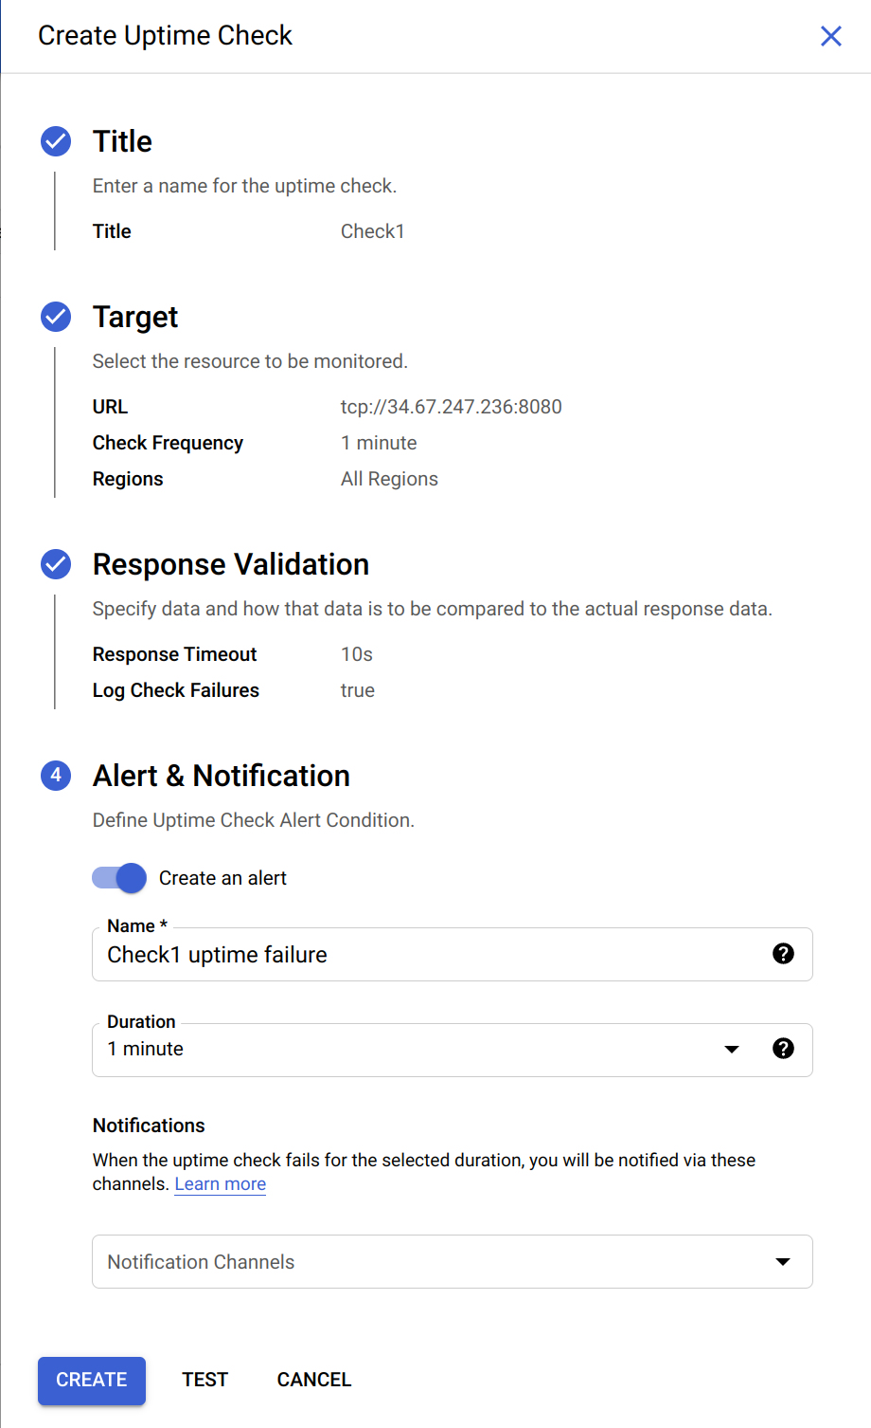

If the test fails, make sure that the service is still working. Also check to see that the firewall rule exists and is correct.

1. After the test succeeds, click **CREATE**.

## Configure an alerting policy and notification

1. Click on **Alerting** > **CREATE POLICY**.
2. Click **Add Condition**.

Set the following in the panel that opens, leave all other fields at their default values.

**Target**: Start typing "VM" in the resource type and metric field, and then select:

* **Resource Type**: VM Instance (gce_instance)
* **Metric**: select a metric you are interested in evaluating, such as **CPU usage** or **CPU utilization**

**Configuration**:

* **Condition**: is above
* **Threshold**: 20
* **For**: 1 minute

Click **ADD**.

1. Click on **Next**.
2. Click on drop down arrow next to **Notification Channels**, then click on **MANAGE NOTIFICATION CHANNELS**. A Notification channels page will open in a new tab.
3. Scroll down the page and click on **ADD NEW** for **Email**.
4. In **Create Email Channel** dialog box, enter your personal email address in the **Email Address** field and a **Display name** and click **SAVE**.
5. Go back to the previous **Create alerting policy** tab and click on the **Refresh icon** to get the display name you mentioned in the previous step.
6. Select your **Display name** and click **OK**. In a later step, you trigger an event that notify you via email.
7. Click on **Next**.
8. Mention the **Alert name** as **Test** and click **SAVE**.

Click **Check my progress** below to check your lab progress.

Configure an Uptime Check and Alert Policy in Cloud Monitoring

Check my progress

## Configure a Dashboard with a Couple of Useful Charts

### **Configure a dashboard**

1. In the left menu, click **Dashboards** > **Create Dashboard**
2. Name the New Dashboard **DMDash**.
3. Click **Line** option in chart library to add the first chart.

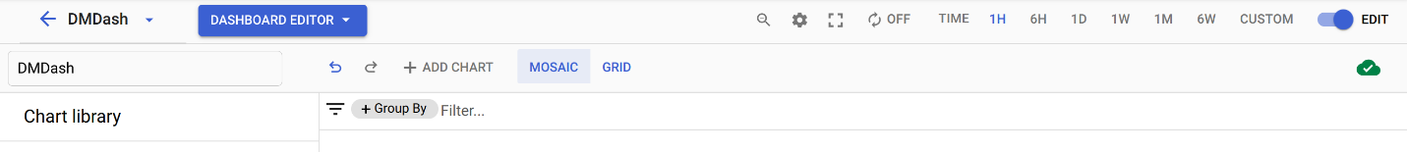

1. Set the following properties:

|  |  |
| --- | --- |
| **Property** | **Value** |
| Chart Title | Sample |
| Resource type | VM Instance |
| Metric | CPU Usage |

1. Click on **+ Add Chart** and select **Line** to add another chart to the dashboard with the following properties:

|  |  |
| --- | --- |
| **Property** | **Value** |
| Chart Title | Sample 2 |
| Resource type | VM Instance |
| Metric | Sent bytes |

1. DMDash should look like this:

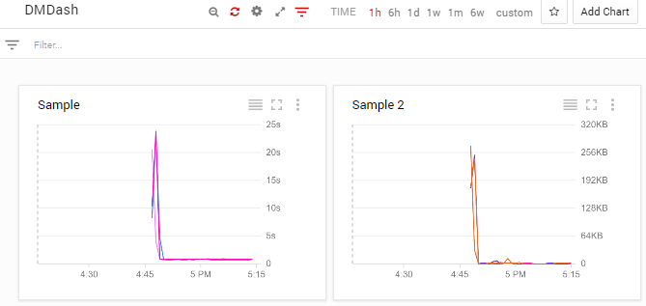

## Create a test VM with ApacheBench

Now that you've configured monitoring for traffic in a specified region, see if it works. You'll install and use ApacheBench to apply 3 levels of load to the service and then view the Cloud Monitoring Dashboard you've set up.

### **Create a VM**

1. In the Cloud Console, click **Compute Engine** > **VM instances**.
2. Click **Create instance**, use all the default settings in the **Create an instance** dialog.

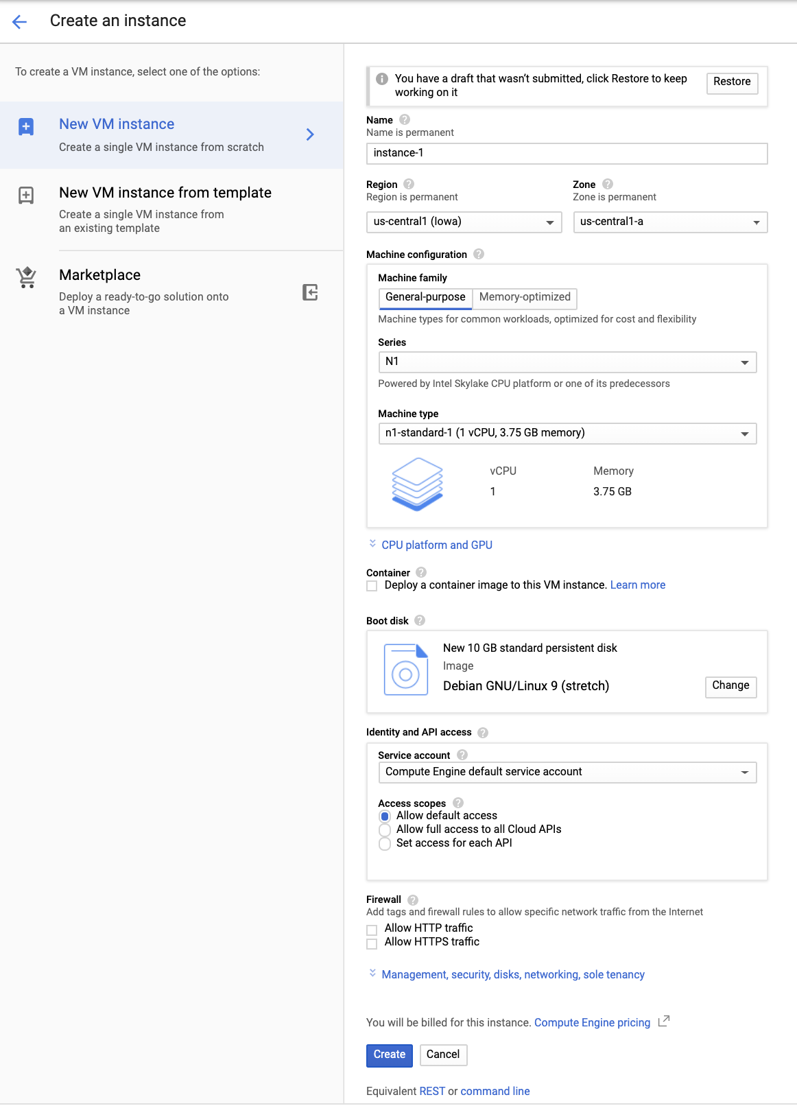

1. Click **Create**.

### **Install ApacheBench**

1. Still in the VM Instances window, click the instance-1 **SSH** button to SSH into the VM you just created.
2. Enter the following commands to install the latest ApacheBench:

sudo apt-get update

content_copy

sudo apt-get -y install apache2-utils

content_copy

Click **Check my progress** below to check your lab progress.

Create a Test VM with ApacheBench.

Check my progress

### **Apply and monitor load**

Now you'll use ApacheBench to apply load to the service. Watch the DMDash dashboard in Cloud Monitoring to monitor the CPU usage and the Network Inbound Traffic. You'll also be able to track the number of instances in Cloud Monitoring by mousing over the lines, or by viewing the instances in the Cloud Console (**Navigation menu** > **Compute Engine** > **VM instances**).

1. In the SSH window, enter this command for ApacheBench to apply load to the service. Replace your forwarding IP for Your_IP (you previously recorded). Run the following command two or three times to create traffic.

ab -n 1000 -c 100 http://<Your_IP>:8080/

content_copy

**Sample output:**

This is ApacheBench, Version 2.3 <$Revision: 1757674 $>

Copyright 1996 Adam Twiss, Zeus Technology Ltd, http://www.zeustech.net/

Licensed to The Apache Software Foundation, http://www.apache.org/

Benchmarking 35.196.195.26 (be patient)

Completed 100 requests

Completed 200 requests

Completed 300 requests

Completed 400 requests

Completed 500 requests

Completed 600 requests

Completed 700 requests

Completed 800 requests

Completed 900 requests

Completed 1000 requests

Finished 1000 requests

Server Software:

Server Hostname: 35.196.195.26

Server Port: 8080

Document Path: /

Document Length: 40 bytes

Concurrency Level: 100

Time taken for tests: 0.824 seconds

Complete requests: 1000

Failed requests: 0

Total transferred: 140000 bytes

HTML transferred: 40000 bytes

Requests per second: 1213.57 [#/sec] (mean)

Time per request: 82.402 [ms] (mean)

Time per request: 0.824 [ms] (mean, across all concurrent requests)

Transfer rate: 165.92 [Kbytes/sec] received

Connection Times (ms)

min mean[+/-sd] median max

Connect: 36 37 0.5 37 40

Processing: 36 43 8.7 38 73

Waiting: 36 43 8.7 38 73

Total: 73 80 9.1 75 112

Percentage of the requests served within a certain time (ms)

50% 75

66% 78

75% 81

80% 84

90% 95

95% 101

98% 106

99% 110

100% 112 (longest request)

content_copy

Wait a few minutes, then increase the load to 5000.

1. Run this command two or three times to create traffic:

ab -n 5000 -c 100 http://<Your_IP>:8080/

content_copy

Wait a few minutes, then increase the load to 10000.

1. Run this command two or three times to create traffic:

ab -n 10000 -c 100 http://<Your_IP>:8080/

content_copy

Now see what happens when you lower the CPU usage per instance.

1. In the cloud console, click **Navigation menu** > **Compute Engine** > **Instance groups**.
2. Click on the name of your instance group, click on the **Details** tab, and then click **Edit Group**.
3. Change the CPU utilization. Click **CPU utilization**, change **Target CPU utilization** to **20**, and then click **Done**.
4. Click **Save**.

The target CPU usage is the total value of the CPU usage for all VMs in the instance group. This controls when autoscaling occurs. In production you would usually have this set to at least 60%. For this exercise you set it temporarily to 20% to make it quicker to examine autoscaling.

Run this command two or three times to create traffic:

ab -n 10000 -c 100 http://<Your_IP>:8080/

content_copy

**Expected behavior:** The load consumed more than 20% of the cumulative CPU in the group, triggering autoscaling. A new instance was started.

Now see what happens when you turn autoscaling off.

1. Go to **Compute Engine** > **Instance groups**.
2. Click the name of your instance group, then **Edit Group**.
3. Change **Autoscaling mode** to **Don't autoscale**.
4. Click **Save**.

Wait a few minutes, then run this command two or three times to create traffic:

ab -n 10000 -c 100 http://<Your_IP>:8080/

content_copy

**Expected behavior:** With autoscaling off, no new instances are created, cumulative CPU usage increases.

### **Results**

There is a lag time of around 5 minutes before you see changes in the Cloud Monitoring Dashboard.

## Simulate a Service Outage

To simulate an outage, remove the firewall.

1. Click **Navigation menu** > **VPC Network** > **Firewall**.
2. Check the box next to the firewall rule which contains **tcp:8080**, then click **Delete** at the top of the page. Click **Delete** again to confirm.
3. You will receive a notification email in 15 to 30 minutes.

## Test your knowledge

Test your knowledge about Google cloud Platform by taking our quiz.

Cloud Monitoring collects metrics, events, and metadata from Google Cloud, Amazon Web Services, hosted uptime probes, application instrumentation, and a variety of common application components including Cassandra, Nginx, Apache Web Server, Elasticsearch, and many others.



True



False

# Set Up and Configure a Cloud Environment in Google Cloud: Challenge Lab

1 hourFree

Rate Lab

## GSP321



## Overview

You must complete a series of tasks within the allocated time period. Instead of following step-by-step instructions, you'll be given a scenario and a set of tasks - you figure out how to complete it on your own! An automated scoring system (shown on this page) will provide feedback on whether you have completed your tasks correctly.

To score 100% you must complete all tasks within the time period!

When you take a Challenge Lab, you will not be taught Google Cloud concepts. To build the solution to the challenge presented, use skills learned from the labs in the quest this challenge lab is part of. You will be expected to extend your learned skills; you will be expected to change default values, but new concepts will not be introduced.

Topics tested:

* Creating and using VPCs and subnets
* Configuring and launching a Deployment Manager configuration
* Creating a Kubernetes cluster
* Configuring and launching a Kubernetes deployment and service
* Setting up stackdriver monitoring
* Configuring an IAM role for an account

This lab is only recommended for students who have completed the labs in the [**Set up and Configure a Cloud Environment in Google Cloud**](https://google.qwiklabs.com/quests/119) quest. Are you up for the challenge?

### **Setup**

#### Before you click the Start Lab button

Read these instructions. Labs are timed and you cannot pause them. The timer, which starts when you click **Start Lab**, shows how long Google Cloud resources will be made available to you.

This Qwiklabs hands-on lab lets you do the lab activities yourself in a real cloud environment, not in a simulation or demo environment. It does so by giving you new, temporary credentials that you use to sign in and access Google Cloud for the duration of the lab.

#### What you need

To complete this lab, you need:

* Access to a standard internet browser (Chrome browser recommended).
* Time to complete the lab.

**Note:** If you already have your own personal Google Cloud account or project, do not use it for this lab.

**Note:** If you are using a Pixelbook, open an Incognito window to run this lab.

## Challenge scenario

As a cloud engineer in Jooli Inc. and recently trained with Google Cloud and Kubernetes you have been asked to help a new team (Griffin) set up their environment. The team has asked for your help and has done some work, but needs you to complete the work.

You are expected to have the skills and knowledge for these tasks so don’t expect step-by-step guides.

You need to complete the following tasks:

* Create a development VPC with three subnets manually
* Create a production VPC with three subnets using a provided Deployment Manager configuration
* Create a bastion that is connected to both VPCs
* Create a development Cloud SQL Instance and connect and prepare the WordPress environment
* Create a Kubernetes cluster in the development VPC for WordPress
* Prepare the Kubernetes cluster for the WordPress environment
* Create a WordPress deployment using the supplied configuration
* Enable monitoring of the cluster via stackdriver
* Provide access for an additional engineer

Some Jooli Inc. standards you should follow:

* Create all resources in the us-east1 region and us-east1-b zone, unless otherwise directed.
* Use the project VPCs.
* Naming is normally team-resource, e.g. an instance could be named **kraken-webserver1**.
* Allocate cost effective resource sizes. Projects are monitored and excessive resource use will result in the containing project's termination (and possibly yours), so beware. This is the guidance the monitoring team is willing to share: unless directed, use n1-standard-1.

### **Your challenge**

You need to help the team with some of their initial work on a new project. They plan to use WordPress and need you to set up a development environment. Some of the work was already done for you, but other parts require your expert skills.

As soon as you sit down at your desk and open your new laptop you receive the following request to complete these tasks. Good luck!

#### Environment

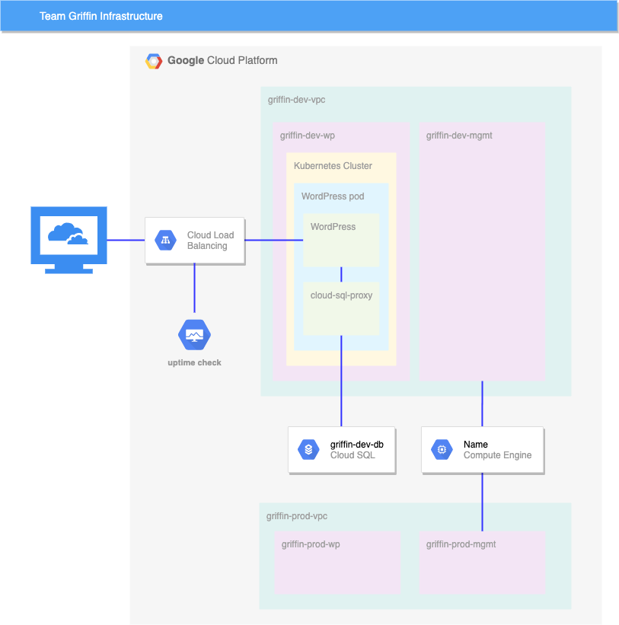

### **Task 1: Create development VPC manually**

Create a VPC called griffin-dev-vpc with the following subnets only:

* griffin-dev-wp
  + IP address block: 192.168.16.0/20
* griffin-dev-mgmt
  + IP address block: 192.168.32.0/20

Click Check my progress to verify the objective.

Create development VPC manually

Check my progress

If you don't get a green check mark, click on the **Score** fly-out on the top right and click **Run Step** on the relevant step. A hint pop up opens to give you advice.

### **Task 2: Create production VPC using Deployment Manager**

Use Cloud Shell and copy all files from gs://cloud-training/gsp321/dm.

Check the Deployment Manager configuration and make any adjustments you need, then use the template to create the production VPC with the 2 subnets.

Click Check my progress to verify the objective.

Create production VPC using Deployment Manager

Check my progress

If you don't get a green check mark, click on the **Score** fly-out on the top right and click **Run Step** on the relevant step. A hint pop up opens to give you advice.

### **Task 3: Create bastion host**

Create a bastion host with two network interfaces, one connected to griffin-dev-mgmt and the other connected to griffin-prod-mgmt. Make sure you can SSH to the host.

Click Check my progress to verify the objective.

Create bastion host

Check my progress

If you don't get a green check mark, click on the **Score** fly-out on the top right and click **Run Step** on the relevant step. A hint pop up opens to give you advice.

### **Task 4: Create and configure Cloud SQL Instance**

Create a **MySQL Cloud SQL Instance** called griffin-dev-db in us-east1. Connect to the instance and run the following SQL commands to prepare the **WordPress** environment:

CREATE DATABASE wordpress;

GRANT ALL PRIVILEGES ON wordpress.* TO "wp_user"@"%" IDENTIFIED BY "stormwind_rules";

FLUSH PRIVILEGES;

content_copy

These SQL statements create the worpdress database and create a user with access to the wordpress dataase.

You will use the username and password in task 6.

Click Check my progress to verify the objective.

Create and configure Cloud SQL Instance

Check my progress

If you don't get a green check mark, click on the **Score** fly-out on the top right and click **Run Step** on the relevant step. A hint pop up opens to give you advice.

### **Task 5: Create Kubernetes cluster**

Create a 2 node cluster (n1-standard-4) called griffin-dev, in the griffin-dev-wp subnet, and in zone us-east1-b.

Click Check my progress to verify the objective.

Create Kubernetes cluster

Check my progress

If you don't get a green check mark, click on the **Score** fly-out on the top right and click **Run Step** on the relevant step. A hint pop up opens to give you advice.

### **Task 6: Prepare the Kubernetes cluster**

Use Cloud Shell and copy all files from gs://cloud-training/gsp321/wp-k8s.

The **WordPress** server needs to access the MySQL database using the username and password you created in task 4. You do this by setting the values as secrets. **WordPress** also needs to store its working files outside the container, so you need to create a volume.

Add the following secrets and volume to the cluster using wp-env.yaml. Make sure you configure the username to wp_user and password to stormwind_rules before creating the configuration.

You also need to provide a key for a service account that was already set up. This service account provides access to the database for a sidecar container. Use the command below to create the key, and then add the key to the Kubernetes environment.

gcloud iam service-accounts keys create key.json \

--iam-account=cloud-sql-proxy@$GOOGLE_CLOUD_PROJECT.iam.gserviceaccount.com

kubectl create secret generic cloudsql-instance-credentials \

--from-file key.json

content_copy

Click Check my progress to verify the objective.

Prepare the Kubernetes cluster

Check my progress

If you don't get a green check mark, click on the **Score** fly-out on the top right and click **Run Step** on the relevant step. A hint pop up opens to give you advice.

### **Task 7: Create a WordPress deployment**

Now you have provisioned the MySQL database, and set up the secrets and volume, you can create the deployment using wp-deployment.yaml. Before you create the deployment you need to edit wp-deployment.yaml and replace **YOUR_SQL_INSTANCE** with griffin-dev-db's **Instance connection name**. Get the **Instance connection name** from your Cloud SQL instance.

After you create your WordPress deployment, create the service with wp-service.yaml.

Once the Load Balancer is created, you can visit the site and ensure you see the **WordPress** site installer. At this point the dev team will take over and complete the install and you move on to the next task.

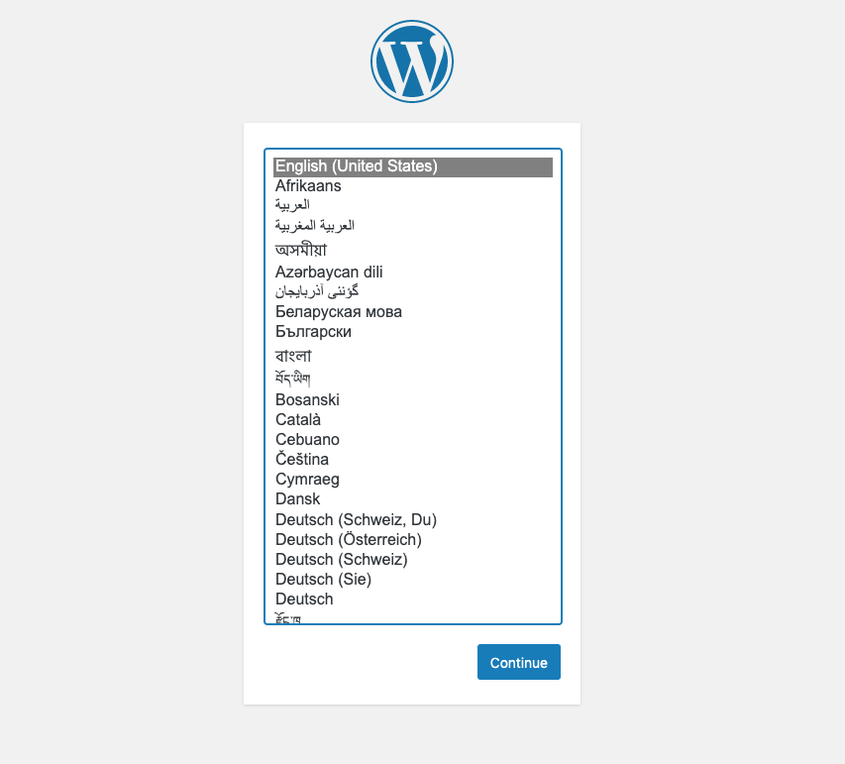

Click Check my progress to verify the objective.

Create a WordPress deployment

Check my progress

If you don't get a green check mark, click on the **Score** fly-out on the top right and click **Run Step** on the relevant step. A hint pop up opens to give you advice.

### **Task 8: Enable monitoring**

Create an uptime check for your WordPress development site.

Click Check my progress to verify the objective.

Enable monitoring

Check my progress

If you don't get a green check mark, click on the **Score** fly-out on the top right and click **Run Step** on the relevant step. A hint pop up opens to give you advice.

### **Task 9: Provide access for an additional engineer**

You have an additional engineer starting and you want to ensure they have access to the project, so please go ahead and grant them the editor role to the project.

The second user account for the lab represents the additional engineer.

Click Check my progress to verify the objective.

Provide access for an additional engineer

Check my progress

If you don't get a green check mark, click on the **Score** fly-out on the top right and click **Run Step** on the relevant step. A hint pop up opens to give you advice.